WELLBEING ACTIVITIES
Breathe: in through your nose for a count of 4 and out your mouth for a count of four. Repeat this several times throughout the day, particularly if you feel anxious or cross.
Use the sheet with The Shield. Think about all the people things that you have around you that are important to you, and keep you safe. Draw them all inside the shield.
Write down 3 things each day that you are grateful for. It can be people, things and experiences – anything!

Use Google Earth to look up the following landmarks: Big Ben, The Eiffel Tower, The Leaning Tower of Pisa and The Statue of Liberty. What else can you find? Did you know that you can also explore under the sea and on the moon? Write down 3 cool things you have found.
It is important to get fresh air, especially if you are feeling a little under the weather. Try the 5-4-3-2-1 grounding exercise when you are outdoors. Working backwards, find 5 things you can hear, 4 things you can see, 3 things you can touch from where you are sitting or standing, 2 things you can smell and one thing you can taste.

Listen: Put on your favourite piece of music and listen. What instruments can you hear? How does the music make you feel? Where in your body can you feel it?

Use the ‘Stay Calm Checklist’ sheet. Write down 7 things you can do to distract yourself when you become frustrated or angry.
Use https://www.cosmickids.com/ to do some fun Yoga exercises. It is important to try and do some exercise while you are at home to keep your body and mind healthy

Listen to an audio book. There are several websites where you can access these for free: Librivox / Spotify (can be used on a free account) / Storynory / Storyline Online.

Find a safe, quiet space and read a book. Use what you can to make your space comfortable.

Ask the adults at home how you can help. Everyone needs to work as a team at times like this, and they will appreciate your help.

Use the ‘Mirror’ sheet. Find a real mirror and look closely at yourself. Make a list of all the things you are good at and the things that you like about yourself. What things make you special and valuable?

15. Use the ‘Suitcase’ sheet. Imagine you have to pack all the important things in your life at the moment. Spend some time being mindful of the people, places, things and thoughts that are the most important. Talk someone through what you have chosen and explain why.
Do a bodyscan. Use the following link to talk you through how to do it: https://soundcloud.com/mindfulmagazine/body-scan-meditation-for-kids

Use the ‘WOW’ sheet. Write or doodle in and around the bubble letters, the things that amaze you! It can be nature, a person, an experience or an item.

Use http://www.hellokids.com/r_12/drawing-for-kids to help you complete a drawing of your choice. Listen carefully to the instructions and complete the drawing to the best of your ability. There is blank paper in the pack to use for this

Go for a mindful walk. It is best to do this outdoors and so you might need to go with a parent or carer. Walk as slowly as you can for one minute. What things do you have time to notice now?

Find ‘The Worst Comic Ever’ sheet. Have fun writing the most rubbish, boring, ugly comic story that you can!

Drawing meditation: Choose an object, look at it very carefully for 60 seconds. Place the item under a cloth and see how well you can draw the item from memory! Do not worry if it isn’t very accurate, just try again with something else!
Each day listen to an inspirational talk! Which was your favourite? How did it change your thinking? https://www.lifehack.org/785441/inspiring-ted-talks-for-kids

Lay down and close your eyes. Listen to some Disney piano music. Try to do activity 1 at the same time. How does it make you feel? https://www.youtube.com/watch?v=5DiMoehAeOU

Listen to a mindfulness story called magic bubbles using this link: https://www.youtube.com/watch?v=SPpTqqHVRKQ

Have fun coming up funny virus drawings and names! Using the ‘Draw Funny Viruses’ sheet.

Use the ‘Smudges and Splatters’ and turn them into pictures!

Showing kindness to others is proven to help YOU feel better too! Can you think of something kind you can do for someone else in your home? Or send a lovely text message to a friend or family member.

Complete the ‘Mindful Colouring’ page. Try to notice what you are thinking about while you do so.

Complete the ‘Olga’s Remedy’ page – make it as weird and wonderful as possible

Use the following ‘Conversation Starters’ to have interesting chats with someone else in your home:

- What is your favourite memory?
- If you were to win the lottery, how would it change your life?
- What are you most proud of?
- What do you want to be doing in 10 years time?
- If you had £1000 to give away who would you give it to and why?
- What makes you happy?
- What would be in your ideal lunch box?
- What is the first thing you notice about people?
- What makes you laugh?
- If you were the Prime Minister, what would you change?
- Who inspires you?
- What is the best thing about being you?
Draw a picture or write a letter to someone at a vulnerable person, eg someone in a local care home.

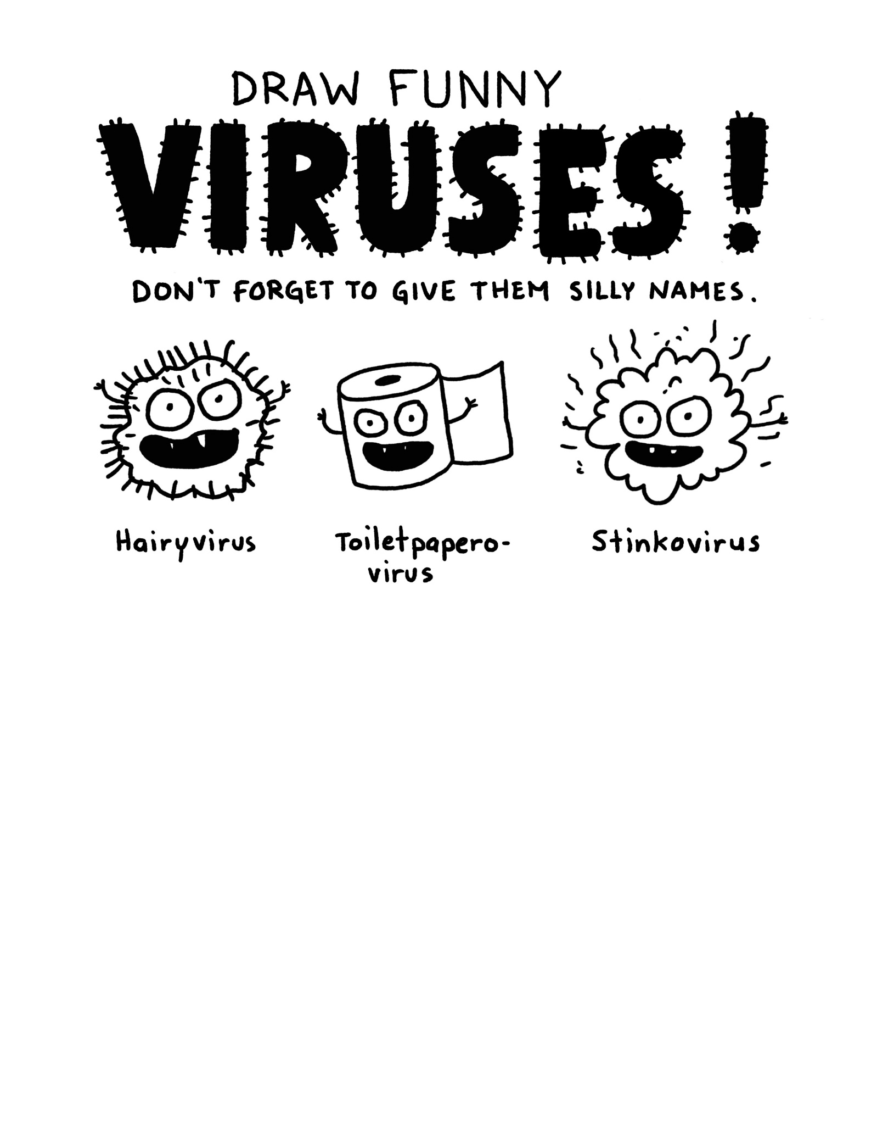
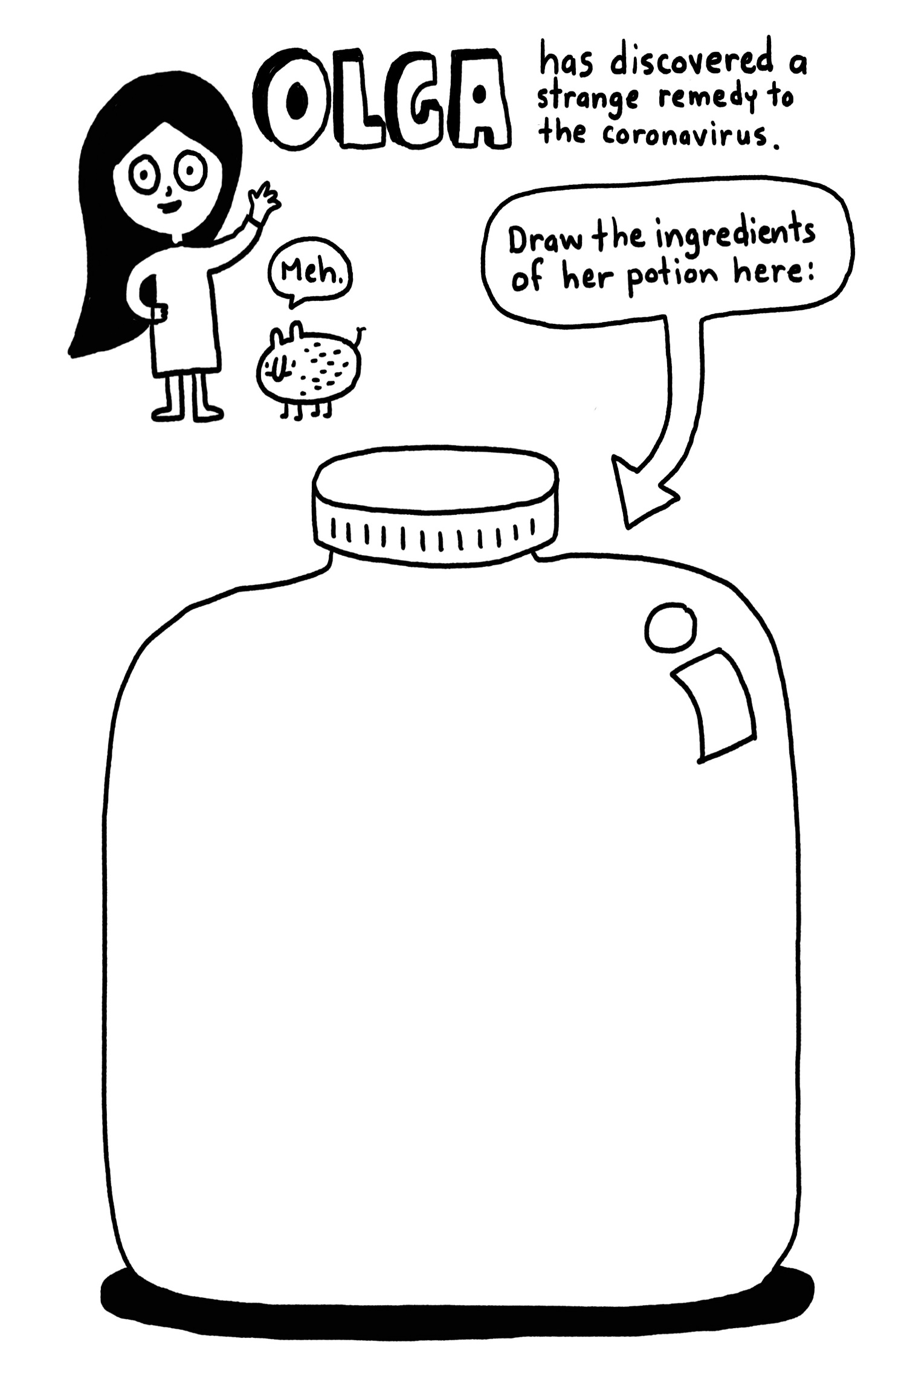
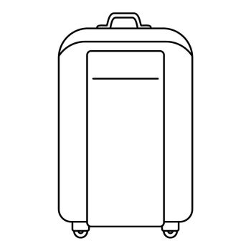
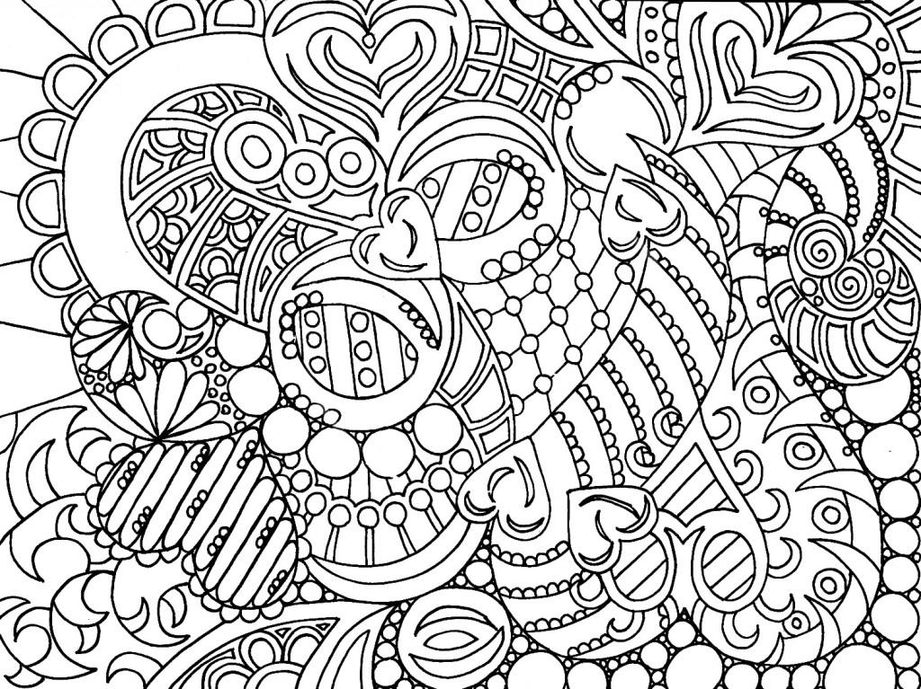
Mindful Colouring
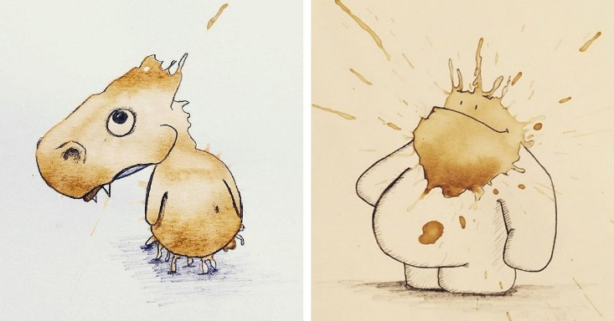
SMUDGES AND SPLATTERS!
There is an artist called Stefan Kuhnigk, who turns his coffee splatters and smudges into cute drawings!
Turn the smudges and splatters below into your own works of art!

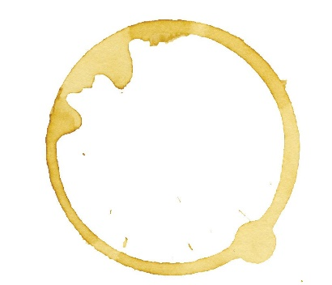

If an adult allows, let them help you make your own paint/tea splatters and turn them into pictures too!

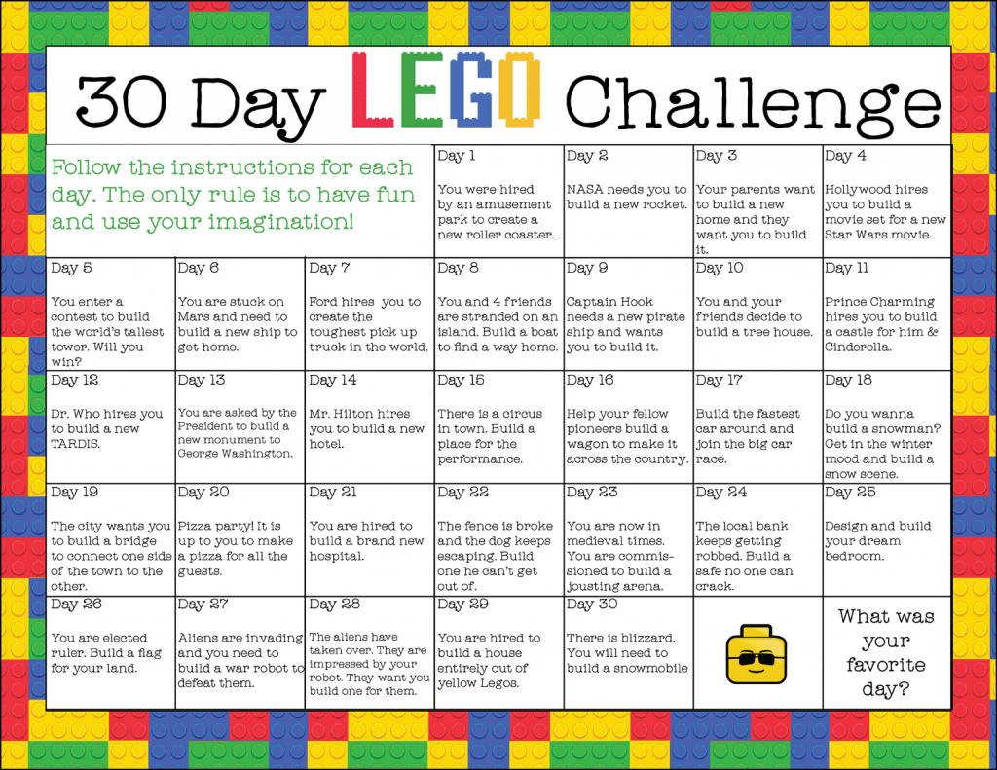
Here are some other websites and challenges to help keep your brain and body moving and learning

