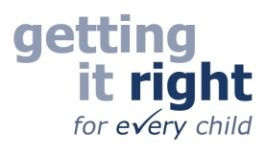**MIDLOTHIAN SPEECH & LANGUAGE THERAPY**

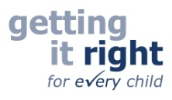

SLT Helpline

**Midlothian Speech & Language Therapy Department offer a weekly telephone help line, for parents and professionals to ring us to discuss any concerns they have about a child’s speech, language and communication skills.**

**For advice or to discuss a child or young person with us please phone**

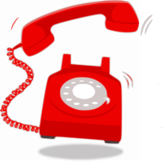

**0131 454 9544**

**on a Tuesday afternoon from 14.00 – 16.00**



**Discussions are confidential but we recommend that consent is gained from parents/carers when raising concerns regarding a child or young person’s development. We may provide you with information, advice or resources, we may signpost to other services and we may recommend assessment by one of our team.**

***If further action is advised we will discuss this with you.***

**Anyone can ring us if they would like to talk to an SLT for advice. You don’t need to go to your GP or school to access this service.**

[www.lets-talk.scot.nhs.uk](http://www.lets-talk.scot.nhs.uk) – **our request for assistance form can be found on our website under Early Years Professionals**

 FindUs logo[www.facebook.com/NHSLothianSLT](http://www.facebook.com/NHSLothianSLT)

