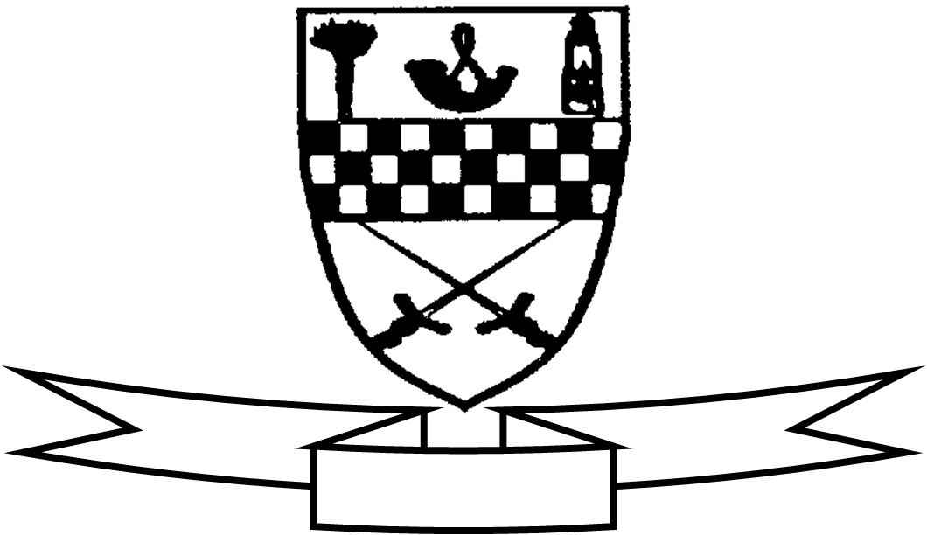

Aim high
Be proud
Celebrate success

Dear Parents/Carers

During last session, classes made excellent use of our Google classrooms to access pieces of learning and work collaboratively. We hope to continue building on these skills throughout this session - for both pupils and staff!

Over the next week, we will be opening up Google classrooms for all of our classes. Initially, Google classrooms will be used to support work, provide small home activities and news from classes as we work to ensure that everyone can get logged in. They will also be a place for Homework instructions to be stored and associated assignments completed. More information on homework will follow in the coming weeks. In the event of a school/class closure by the Scottish Government, class work would move into the Google classroom therefore it is important that we ensure children are able to access their Google classroom through their Glow account.

Instructions for logging into Glow are given below and are the same as last year.
Please read the following information carefully:

- Usernames have not changed. Your child’s username begins with “mc” and then includes the first 5 letters of their surname, their first initial and 2 digits (an example might be mcjonesm45). Usernames were given out in March to P2 to P7 children. Please email the school email address if you need a reminder of this username (mauricewood_ps@midlothian.gov.uk).
- Glow passwords have been reset for this session. For P3 to P7 the password is
“new pass” with no capitals and a space in between the words. Once you log in using your child’s username and the new pass password, you will be prompted to change the password. Please make sure you make this memorable as school will not know the new password and there will be a delay in getting these reset. For P2 children, their password has been set to “reddog” (with no capitals and no space) and they will not be prompted to change this.
- P1B, P1W, P1/2 and P2A pupils will receive their new Glow username and password through a message on Seesaw.
- The Glow platform has had a refresh over the Summer so login screens and backgrounds may look different but icons are still in the same place. Click the temple once logged in to find the Google classroom tile.
- When logging in for the first time, you will be asked to “verify” the account.

The codes for Google Classrooms are given below alongside information on how to log in.
If you would like to see video tutorials to find out more about Glow and Google Classrooms you can visit the Midlothian homepage at www.athena.mgfl.net and click on the purple tab for Distance Learning information for parents.
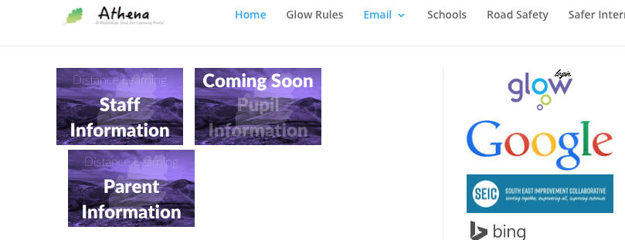

Each class in Mauricewood has their own individual Google classroom. Below are the codes for the classes and we ask that you only allow your child to access their own class to avoid any miscommunication and errors. Any parent of any child can access the Support for Learning classroom, regardless of whether their child has been working with our Support for Learning teachers.

Children of all ages are also welcome in the Home Learning Hub classroom. This is a classroom space for children who, at any time and for any reason, may be learning from home. If your child is required to stay at home and is well enough to manage some learning, there are grids for each school level (these are also available on the School App and will be updated regularly). Any work completed can be shared in this Google classroom and any questions from home can be shared on the Stream where a member of staff will reply.

Google Classroom Class Codes
P1B 2020/21 | mncjbps
P1W 2020/21 | p5bqxko
P1/2 2020/21 | t75gocn
P2A 2020/21 | 3qiujg7
P2/3 2020/21 | 64un3wy
P3L 2020/21 | y2ww47o
P4B 2020/21 | ss46nuy
P4S 2020/21 | 2ipu7x4
P5R 2020/21 | rlgwcuj
P5B 2020/21 | ifbyq7x
P6M 2020/21 | 4luh5xq
P6C 2020/21 | a2zovx5
P7L 2020/21 | gp2xqaf
P7N 2020/21 | uw7ag4f
SfL (available to all learners) | yjl5i5z
Home Learning Hub (for any learners working from home) | rtql37w

To access your child’s own classroom, click the + button in the top right corner and enter the correct class code. You will only need to do this once.

There are two sections in the Google Classroom. One is called Stream and the other is called Classwork.

The Stream can be used for quick questions to teachers and to share any learning achievements from home. We ask that this is not a place for children to “chat” with one another as it becomes incredibly crowded, although many of our learners have used it to support one another’s learning questions.

Classwork is where your child’s teacher will set work/homework to be handed in. Work can be handed in using several methods and all are acceptable. If work is handwritten, a photo can be uploaded. If work is created digitally (perhaps on Word, Powerpoint or Book Creator) then this can be attached in the Classwork section. There may also be work examples, videos and learning tools that are posted in the classroom to aid with the week’s work.

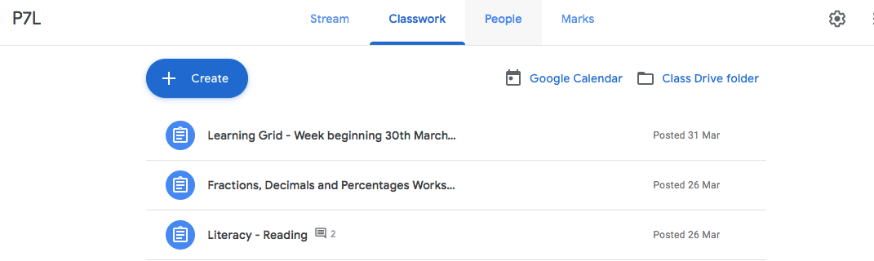

As we find our way through this way of working again, we are asking for your support in keeping our online classrooms positive spaces - as our classrooms are in real life! We have begun work in school on being digital citizens and behaving online in the same kind manner that we expect in school. At Mauricewood, we have 3 rules for feedback - Be Kind, Be Specific, Be Helpful - and we do ask that these are followed in the online classroom too.

Kind regards,
The Mauricewood Team

