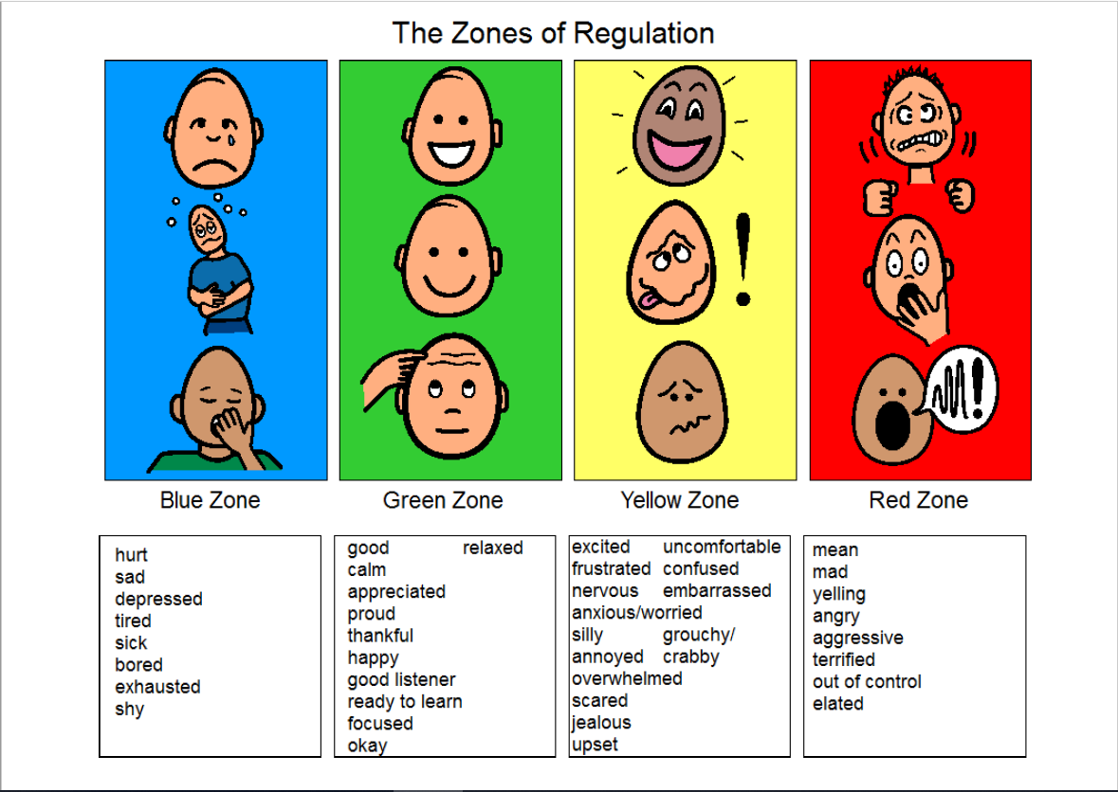
- The Zones of Regulation is a fun way of helping children learn emotion words, understand how other people are feeling, and how they are feeling.
- It puts our emotions and states of alertness (low energy to high energy) into 4 coloured ‘zones’
- It is ok to be in any of the zones – there are no ‘good’ or ‘bad’ zones, we all move between each of the zones (probably everyday!)
- We want to be in the green zone as much as we can, so that we feel calm and ready to listen and learn. But we can’t be expected to be in the green zone all of the time
- If we are in the blue zone we have lower energy, so often need to do things to give us energy, or rest
- If we are in the yellow or red zones we have more energy, so might need to do things to help us calm down
- When we get into the red zone, we need to stop and have time to calm down. It is very hard for us to think and listen to others when we are in the red zone
Talking about our feelings is really important for people of all ages, but if we can model this more at home/school/nursery, it will help children feel more confident in doing this.

Here are some fun ways you can use the Zones of Regulation at home;
- Use it to talk about how you are feeling throughout the day, e.g. “I’m feeling in the blue zone this morning, I’m tired because I went to bed late” or “I’m in the yellow zone, because I’m excited about playing a game”. This is a nice thing to do as a whole family, as it will help your children feel comfortable talking about how they are feeling and will help them to develop their vocabulary of emotion words
- Have a way of ‘checking-in’ with your family, to show everyone which zone you are in. For example, have a copy of the poster on your fridge and use a magnet for each person to put over which zone they feel they are in
- Talk about how characters in favourite story books are feeling, e.g. “the snake was terrified and in the red zone, because he thought the Gruffalo was going to eat him”
- You might even want to have a think about some of the tools you or your child is already using to help manage how they’re feeling. It is helpful for your child if you also talk about the things that you do, e.g. “when I’m feeling sad and in the blue zone I find someone to talk to” or “when I’m feeling nervous and in the yellow zone, I take some deep breaths and that helps me to feel calm and get back to the green zone”
