Gore Glen Early Learning and Childcare

Family information and handbook
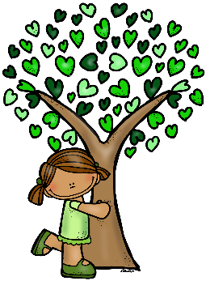
General Information
Gore Glen Early Learning and Childcare currently provides 1140 hours provision following the guidelines set by the Scottish Government amidst the Coronavirus pandemic.

Gore Glen Early Learning and Childcare
Whitehouse Way
Gorebridge
Midlothian
EH23 4FP

Telephone: 0131 444 9026
E-mail: Goreglen_ps@midlothian.gov.uk
Web: www.goreglenprimary.co.uk

Staff
Head Teacher Mrs Jennifer Allison (Acting)

Deputy Head Teacher Mr Gillon Rand

Senior Early Years Practitioner Ms Lynne Doig

Early Years Practitioners Miss Nik Clark
Mrs Wendy Crawford
Miss Louise Kings
Miss Jane Libberton
Mrs Maria Moyes
Miss Tammy Pagan
Mrs Kim Vass
Mrs Leona Westwood
Early Years Learning Assistant Miss Melissa Thomson

School Staff – Administration Mrs Loraine Wood
Mrs Lisa McWhinnie
Mrs Jenni Tait

Early Learning and Childcare Hours
Our core hours are:
Monday - Thursday – 08.30/15.05
Friday – 08.30/12.10pm
It is advisable to return for your child promptly to allow time to chat to the staff about your child’s day and to collect their day’s artwork and creations that your child wishes to take home. If you know that you are going to be unavoidably late, please contact the ELC team so that alternative arrangements can be made for your child to be cared for.

What to bring to the ELC?

We would prefer your child to have indoor shoes that are different to their outdoor shoes. This supports your child’s development, promoting their independence in being able to dress themselves. There are shoe racks and baskets in the ELC for the children to put their swapped shoes on. Children need to be comfortably dressed and appropriately dressed for the weather. Waterproofs and wellies for wet days, sun cream and sunhats for sunny days. We operate an open-door policy where the children are free to move indoors and out as they choose. WE WILL BE OUTDOORS IN ALL WEATHERS. Following the pandemic of COVID-19, it is really important that each child has their own waterproofs and wellies to prevent the cross contamination of use. Our Early Learning and Childcare provision is unable to supply these at this time. Sun cream is expected to be applied at home before arriving at our ELC. It is advised that a bottle of sun cream with your child’s name and date of opening is left in their tray, Midlothian Council operate a policy where it is not expected of nursery staff to administer sun cream to the children in their care other than to top up previously applied cream.
As we encourage children to be as independent as possible, please remember that some fastenings are tricky for little fingers: dungarees can be difficult to undo when children go to the toilet and laces can be tricky when children go outdoors.

Starting Gore Glen Early Learning and Childcare
Starting ELC is a big step for children. There are many new experiences, new people to meet and new routines to adjust to. Every child will cope with these experiences in a different way and so we adopt different strategies to settle each child.
With the current guidelines set by the Scottish Government, following the COVID-19 pandemic our transition to our ELC provision will be slightly different. For your child’s initial visit, we will be meeting in the garden. Thereafter, an agreement will be made between staff, your child and yourself as to how we will invite your child to join us and continue with the settling in process. Some children will settle quickly whilst others may take a little longer but with patience and understanding we are certain that your child will soon feel safe and secure in this new and challenging environment.

There are several ways in which you can help:
* Encourage your child to feel enthusiastic about attending Gore Glen ELC.
* Make sure they know that you will not leave until they are happy for you to go.
* Involve yourself in what your child is doing whilst you are in the setting during the settling in process.
* Always say “Goodbye” and tell your child when you will be back.
* When you return encourage your child to tell you what they have been doing while in our setting.
* Although there can be tears at first most children do settle well eventually and it can be better for the children to learn that parents do not stay with them in the ELC, talk to your child and explain that you are going for a short time, but you will come back later.

Health
If your child is feeling unwell, it is much better for them to be at home, rather than in a busy learning environment. Germs can spread quickly in an atmosphere where children are continually coughing or sneezing.
If your child is suffering from sickness or diarrhoea please keep them off Nursery for at least 48 hours after their last bout, to avoid spreading any infection.
Please contact the ELC if your child is suffering from an infectious or contagious disease or is likely to have a prolonged absence.
Should your child be on any regular medication please inform our Early Years Practitioners who will support your child with a relevant care plan that ensures your child’s needs are being met.
Please also inform our practitioners of any allergies that your child may have. A care plan will be written to support their needs.
We are very conscious of Health and Safety regulations both inside and outside the Nursery. Practitioners and the children make informed Risk Assessments daily. Unfortunately, accidents sometimes happen and are treated using simple First Aid procedures and parents/carers will be informed. Gore Glen ELC follows the Midlothian Child Protection policy guidelines to ensure the welfare of all children.

Snack
Snack time at Nursery is a time for children to relax with friends and enjoy a tasty nibble. Milk is provided by the Education Authority and water is provided daily. We try to encourage healthy eating habits and encourage children to try a variety of foods; however, children choose whether to eat.

Snack is provided twice daily for your child along with a hot meal at lunch. Milk is provided daily for each child.

Safety and Security

The safety and security of your child in our care is of paramount importance. We have regular fire drills and procedures for the children to learn. These few simple rules listed below can help to ensure the safety of all children in our care and we ask for your help in this matter.

* A responsible person over 16 should drop off and collect your child at the end of the day.
* If this is someone other than you please inform a member of staff.
* The ELC front door is our primary fire exit so we ask if you can always keep this area clear.
Positive behaviour approach
We aim to help children to achieve a balance between being assertive and considering the needs of others. We try to discuss any problems with children and help them to resolve the situation themselves in a positive and understanding way, building empathy and caring in each child. We encourage and praise the kind of behaviour we want to see and, as adults in the ELC environment; we hope to set a good example of the behaviour we want children to adopt e.g. respecting each other, being polite etc.

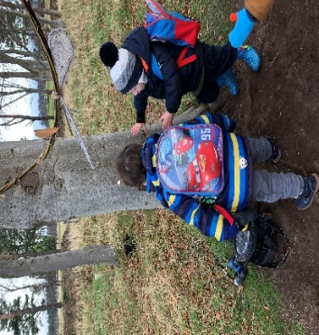
Photographs
We often take photos of your child in the ELC to use for a variety of reasons. These include reminding children of outings they have been on or visitors who have come in to our ELC, as a record of any achievement your child has made - a model they are particularly proud of or as a record of events to inform parents and visitors of the ongoing curriculum. We require parental permission to photograph your child. Forms will be given out on your child’s first day at our ELC.

Beliefs, Values and aims of the nursery
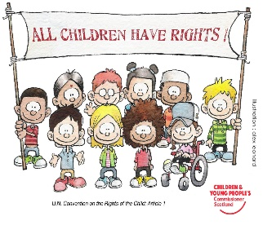
The vital contribution of Early Learning and Childcare lies in developing and broadening the range of children’s learning experiences, to make them confident, eager and enthusiastic learners pursuing a life-long love of learning through play and wonder, establishing a network of lasting, meaningful relationships and understanding the society and environment in which they live.
The Gore Glen Way:

I am: Being Safe
Being Kind (being respectful)
Being ready to play (being ready to learn)

Gore Glen Early Learning and Childcare Principles:
Unity and Connectedness:
We believe that nature provides wonderful object lessons for life. We believe that in order for a child to take care of ‘the earth, he must first love the earth; our job is to put the child in sympathy with nature so that relationship can happen. We believe that children are whole beings, whose thoughts, feelings and actions are interrelated. We believe that young children learn in a holistic way, everything links in our learning.

Creativity and the Power of symbols:
We believe that natural materials provide a higher play affordance than manufactured toys.
We believe children should use real tools for real jobs.
Supported by a nurturing environment and people we believe that creativity is about children representing their own ideas. Children use and make symbols to express their inner thoughts and ideas to make meanings and reflections of everyday life, community and culture.

The central importance of play
We believe that children have ownership of their play.
We believe in long stretches of purposeful play and exploration.
We believe that children’s inner worlds of feelings, ideas and lived experiences take them to new levels of thinking, feeling, imagination and creativity as a resource for the future.
We believe in ‘Freedom with guidance’ – meaning the educator values the contribution of adults supporting children’s enriched play.

Engaging with nature
We believe that nature is the best classroom providing abundant inspiration for the child.

Knowledgeable nurturing educators
We believe that an educator’s role is not to lecture or fill the child with information, but rather to be silent, observe, ask questions and be wonder filled alongside the child.
We believe that children should be consulted, and their voices should be celebrated.

The value of childhood in its own right
We believe ‘academic readiness’ is getting a child ready for life, not school.
We value learning begins at birth and continues throughout life

Autonomous learners
Each child is unique and what they can do rather than what they cannot do is our starting point.
We believe that risk is necessary in helping CHILDREN form boundaries and keep safe.

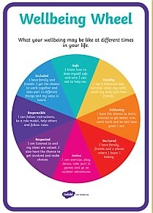

Our beliefs and values are underpinned by the Getting It Right for Every Child guideline which are displayed, along with the United Nations Convention for the Rights of the Child articles in the nursery front hall.
We ensure the well-being of all our ELC children’s needs are being met.

Gore Glen Early Learning and Childcare Aims
Our ELC practitioners take a child-led approach, with the individual child leading their learning. We provide rich and meaningful opportunities for the child to enquire, discover and wonder about their learning. The resources in our ELC are open-ended and de-constructed, this allows the child to learn through creating and imagination, making their own play dough lends experiences to mathematics – measuring, science – many ingredients some of wet, some of dry mixed together become one textured and interesting medium to play.
Each term we aim to participate in a block of Forest School sessions, where the children are encouraged to explore the outdoors, take informed risks in their play by experimenting in what their bodies are capable of and learn about how nature is wondrous and great for our health and well-being. Information will be given to you before each session commences.

Curriculum Guidelines
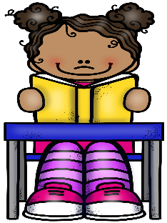
The aims of Curriculum for Excellence are to develop the skills of lifelong learning and to encourage children to be –

Successful Learners
Confident Individuals
Responsible Citizens
and
Effective Contributors

Curriculum for Excellence is designed to achieve a transformation in education in Scotland by providing a coherent, more flexible and enriched curriculum from 3 to 18. The term curriculum is understood to mean - everything that is planned for children and young people throughout their education, not just what happens in the classroom.
Curriculum for Excellence includes four contexts for learning:
- Curriculum areas and subjects
- Interdisciplinary learning
- Ethos and life of the school
- Opportunities for personal achievement.

These ideals are encouraged throughout a child’s education from 3-18 years old. Continuity throughout the early levels (Nursery to P2) will be specifically encouraged to allow a smooth transition process and a coherent sense of community throughout the school. The ELC class will take part in suitable school activities which are appropriate to the maturity of our children.
Observations and learning documents
Through careful observations of the child’s development and skill building along with enriching the child’s interests, observations of children’s progress will determine the specific activities and extended learning opportunities. There will be identified ‘possible lines of development for each child’ which will be appropriately discussed with children encouraging them to look at their own learning and identify their own development needs. We involve parents and carers in this process too, there are opportunities for you to share your child’s achievements from home such as sleeping through the night. Parents will also be asked to participate in consultations twice a year, this is where you will be given the opportunity to discuss your child’s needs. Your child’s voice will also be encapsulated in their learning, through conversations that have been had or retrospectively when they are looking at their learning journals. Our journals will be online via an App called ‘Seesaw’ you will be given a specific log in for your child. This is a secure app where there are no external visitors. Your child’s learning is only visible between your family and the practitioners. Group activities that are recorded are visible by the families tagged in that group.

Raising Standards
In keeping with current legislation to continually raise standards and improve the service offered to you and your children, all Early Learning and Childcare settings are subject to an inspection on a biennial basis. Parents shall be informed of the dates of the inspection when known.
We use our Early Learning and Childcare Improvement Plan to aid self-assessment of our procedures and policies. We always welcome the opinions of children and parents on the quality of service provided. Formal opportunities for parents/carers to feedback their news are organised every year. If you are unhappy with any aspect of the service and wish to lodge a formal complaint, please contact the Senior Early Years Practitioner/Head teacher to discuss the issue and if this process is unsatisfactory, a complaints form is available from the school office or alternatively you can contact the Care Inspectorate direct by telephone 0345 600 9527 or via the website http://www.careinspectorate.com

Partnership
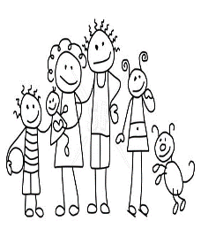
Parent helpers are always very welcome into our setting and can participate in a variety of ways e.g. working with groups of children, helping on outings and demonstrating skills. Parents are also involved in the life of the Nursery by helping at fund-raising events, attending open evenings, meetings and taking part in social events.
School and home play an essential role in children’s learning and behaviour.
Therefore, it is important that relationships are built on mutual trust and respect, and that practical, meaningful lines of communication are created to enable a free two-way flow of information.
Parent consultations will take place twice a year, your child will receive a transition report the term before they start school. Regular questionnaires are sent out to our families as part of our self-evaluation process. This gives you and your child a voice in how the nursery is working and if improvements are required. The nursery team are always pleased to discuss any concerns and answer questions. If necessary, it is possible to hold more formal meetings at any time during the school year by arranging a mutually suitable time.
A regular newsletter is also issued to parents giving information of activities, visits etc. This will be available by e-mail or paper form on request.

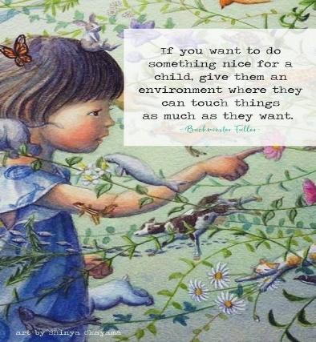
Welcome to our Gore Glen
Early Learning & Childcare
Family

