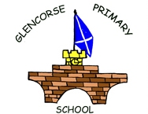
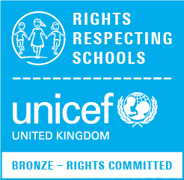
GLENCORSE PRIMARY SCHOOL
‘A small school building big dreams’

Monday 16th March 2020

Dear Parent/Carer

This is an update to give you information on how were are moving forward in line with NHS guidance on Covid-19 (Coronavirus) in school.

As a result of the constantly changing situation, the decision has been made to postpone Parents Evening on Wednesday 25th and Thursday 26th March, the P7 meeting for Benmore Camp at Mauricewood Primary on Thursday 19th March and our French Café morning at the end of term. New dates will be distributed when the situation settles.

Families are required to follow NHS guidance. This means children who have a temperature/fever above 37.8C or new continuous dry cough should self-isolate at home for 7 days. If your child develops these symptoms whilst at school, we will call you to collect them and again they must stay at home for 7 days.

Families should also ensure they are following official guidance on self-isolation. Guidance on this can be found in various places including NHS Inform.

In school we are following the most current guidance from NHS and Care Inspectorate for Educational/Care establishments as follows:

- Regular handwashing – all adults and children should wash hands on arrival at school and regularly throughout the day particularly before snacks, meals and after outside play.

- Catch It, Bin It, Kill It. Everyone is being reminded to catch sneezes/runny noses with tissues which are then immediately binned. Hands are then washed.

- We are following reporting guidelines to the authorities if there are any suspected or confirmed cases.

- Cleaning guidelines are being followed in school.

Please inform school if your contact details have changed. Please ensure that you have at least two contact details registered with us. Thank you.

If you have any questions please don’t hesitate to contact me.

Yours sincerely

Julie Barnes
Headteacher

