Danderhall After School Club
danderhall.asc@gmail.com

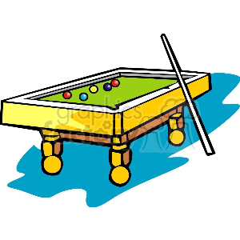
Play pool
Relax
Danderhall After School club
Let your children play, relax or be creative
Children are care for by qualified staff
Play with their friend’s
Children have a healthy snack when they arrive
Outdoor play and indoor play are available to all at all times.
Daily sessions for children from the age of four
Pick up from Nursery and Playgroup
Daily sessions £9.35
Outdoor Games Arts and crafts
This Photo by Unknown Author is licensed under CC BY-SA-NC

