|  |  |  |  |  |
| --- | --- | --- | --- | --- |
| **Dyslexia Information Booklet**  **Seniors**  FAQs about Dyslexia from the British Dyslexia Association | Kip McGrath  Ashby  Dyslexia Services – Special Programs – Diboll Independent School District  **Dyslexia Study Tips**  **C:\Users\frasel95\AppData\Local\Microsoft\Windows\INetCache\Content.MSO\90581E3C.tmp**  **Anyone with dyslexia knows that studying can be very frustrating. You re-read the same text but feel like you're getting nowhere.**  If this sounds like you, don’t despair. Follow these study tips to help break down the barriers that dyslexia creates.  **1: Study in the same place**  By going to your “study place” you get into “study mode” straight away. You might like to wear earplugs to block out the sounds of other students. It’s also a good idea to sit at the same table in class because this will help you feel more relaxed and focused.  **2: Notes**  When reading, circle the important sections and make notes in the margins. This will help you quickly find what you need when you read the text again.  **3: Use colour**  Use different coloured highlighters to highlight different kinds of information. Don’t go too crazy with the colours though- just highlight the most relevant stuff or you will end up with a multi-coloured page!  **4: Take notes in class**  It’s difficult to know how much you need to note down. Try to be selective in your note-taking and put smiley faces next to the information which you think is most important. The symbols will help you find what you need when you skim through the notes later on.  **5: Check, check and double check!**  hand pointing bookTry to check your answers at least once before handing in your work. Be especially careful with numbers as these can easily get jumbled up!  **6: Cut out the glare**  If you lose your place when reading, get hold of a special [**coloured plastic overlay**](http://www.crossboweducation.com/dyslexia_and_visual__stress_work.htm) to place over the page, or a [**reading ruler**](http://www.crossboweducation.com/dyslexia_and_visual__stress_work.htm). These will cut out the glare and make the text clearer, helping you to keep your place. If working on the computer, try to get hold of a [**monitor overlay**](http://www.crossboweducation.com/anti_screen_glare.htm) which will also cut out the glare.  **7: Print useful information onto coloured paper**  This will help you focus on the page. Try to avoid using shiny paper though!  **dyslexia study tips star**  **8: Use spell checker**  If working on the computer, it’s always worth running a spellcheck. It’s quick and easy to use and will save you time and trouble.  **9: Create visual planners**  When writing essays, use spider diagrams to jot down your ideas and link them together. This will help you map the essay. When planning your time either for studying or revision, do a weekly wall chart and use symbols for visual techniques.  **Strategies for Dyslexia**  All, or some of the information below may be useful strategies for dyslexia.  **C:\Documents and Settings\frasel95\Local Settings\Temporary Internet Files\Content.IE5\ORSNIB4I\MC900240565[1].wmf**Working Memory   * Repeat instructions * Check your understanding * Short, clear instructions – one at a time * Memory aids * Extra time to process information * Printed handouts * Mind maps/diagrams * Word bank * Prompt to keep you on task   C:\Documents and Settings\frasel95\Local Settings\Temporary Internet Files\Content.IE5\ORSNIB4I\MP900427825[1].jpgWriting/Handwriting/Notes   * Limit copying from the board or books * Photocopy notes or use worksheets * Ask for extra time to complete work * Use ICT where possible * Use typed notes on key points (provided by teacher) * Use a framework for writing notes (provided by teacher) * Use plenty of space, headings and colour when making notes/diagrams * Revision books can help if you find it difficult to summarise text   C:\Documents and Settings\frasel95\Local Settings\Temporary Internet Files\Content.IE5\F13ISGE3\MC900383640[1].wmfReading   * Use visual prompts to help you * Share reading with a partner -turn taking * Adapt font size/enlarge text * Use coloured paper/overlay to reduce glare * Use sequencing to understand what’s happened in the text * Extra time to re-read worksheets/materials * Have a dictionary to help with new vocabulary * Use a ruler to help you follow the line   C:\Documents and Settings\frasel95\Local Settings\Temporary Internet Files\Content.IE5\F13ISGE3\MC900089058[1].wmf  Spelling   * Use a spell checker * Use a subject specific word bank * Use the Look, Cover and Write method to improve spelling   **Study Tips and Revision Aids**  Some useful tips to help with your studying/revision:   * Coloured overlays * Post-its * Index cards * IPod or I phone * Revision apps * Bullet points * Skim reading * Concise your notes * Key points * Mind maps * Plan your revision * Timer/clock * Revise in short chunks 20-25 mins * Type your notes * Important facts first * Use terms or glossary * Use Mnemonics as a memory aid * Join or make your own study group * Listen to music if it helps you concentrate ( classical very good for this) * Make a study timetable * Find a quiet study place * Learn to say “no” when you get a call from your friends * Use highlighters * Make lists * Don’t procrastinate i.e. Excuses won’t do!!!! * Use pictures to jot your memory * Make a PowerPoint of your notes * Revise with a friend * Make up a personalised quiz for each subject     **Dyslexia Information Sheet**  *Make a list of the strategies you use to help your learning – in class or at home.*   |  | | --- | | 1.  2.  3.  4.  5. |   What tools do you use in class to support your learning?   |  | | --- | | 1.  2.  3.  4.  5. |   Circle the relevant study techniques you use when revising for exams/ assessments.   |  | | --- | | ICT Summarise notes  Mind maps Different coloured folders for subjects  Highlighters Mobile phone apps  Post Its Plan your revision  Concise your notes Coloured overlay  Revise in short chunks Join a study group  Revise with a friend Attend study classes at school |  |  | | --- | | Note any other useful strategies: |   http://www.youngscot.org/file/760343eb-d4db-4415-9552-a26d00c25944  **Challenges associated with dyslexia:**   * Problems with reading, taking notes, remembering numbers, names and details. * Difficulty with time keeping, managing time, organising work etc. * Problems with written work e.g. spelling and writing. * Short-term memory problems.   **Strengths associated with dyslexia:**   * Being very creative and enjoying practical tasks. * Strong visual thinking skills e.g. see/think in 3D. Good verbal skills and good social interaction. * Being good at problem solving. * Dyslexia can affect anyone and is different for everyone. It is not a disability; it is a difference in the way you learn.   [Home](https://unwrapped.dyslexiascotland.org.uk/)  **Hello**  Welcome to Dyslexia Unwrapped, the online hub for young people with dyslexia. It’s fun, informative and designed just for you. Watch a video, find support, get involved!  **Info and support**  Click on your age to find useful articles and information about living with dyslexia. Whether you’re struggling with time management, or need support from your teachers and friends, we can help.  [**So, you've got dyslexia...**](http://unwrapped.dyslexiascotland.org.uk/info-and-support/so-youve-got-dyslexia-what-is-it-anyway)  Find out what this means – and what it doesn’t!  Lots of useful stuff for you, your parents and friends.  **Information for Parents/Carers**  Assistive Technology  There is a wide range of PC hardware and software as well as a number of handheld devices that are specifically designed to make life easier for people with dyslexia.  These are all included within the heading of “Assistive Technology”.  Examples of the technology that are suitable for people of all ages are provided below.  **Chromebooks** are issued to some pupils at Dalkeith High School. They offer a great benefit for learning in class. Training is given when the Chromebook is issued so that pupils are aware of how they can use the Chromebook effectively in class and at home.  **Speech recognition** software. This allows users to dictate or talk to a computer that uses software to convert this to text.  This is clearly of interest to individuals that might otherwise have difficulty with spelling or writing emails, reports or other written communications.  **Text-to-speech** software. This allows individuals to understand written material they are presented with and to proof-read or check their own work.    **Mind mapping** software. This is specifically designed to allow dyslexics to plan their work more effectively.    **Scanning software and hand reading pens**. These allow the user to store and listen to the text found in books and other documents.    **Spell checkers** that are specifically designed with dyslexia in mind to automatically make corrections to written communications.    **Smartpens** can be used to write text, but which track the text being written and recreate the notes in digital form.  The pen can then upload the text to a smart phone, PC or tablet to allow further processing or electronic distribution.   A number of different models are available on the market, each with different strengths and weaknesses.    **Tablets, Smartphones and Applications**. There are a wide range of hardware platforms and software applications that can help individuals to manage their time and task list more effectively or work in conjunction with other hardware devices such as smartpens.    **Computer based learning programs**. These are specifically written for dyslexics and can help to sharpen their skills in reading, writing, touch-typing and numeracy.  **Useful Resources**  https://dalkeith.mgfl.net/files/2014/08/2-SUPPORT-FOR-LEARNING-LOGO-yiongu-e1426670131438.pngFor further information on dyslexia, go to Dalkeith High School’s website, Support for Learning Department and then Dyslexia Information. You will find useful resources on organisational skills, planning, strategies and informative websites for students, parents and carers.    **Read and Write**  **C:\Users\frasel95\AppData\Local\Microsoft\Windows\INetCache\Content.MSO\7A5A2623.tmp**  The purple jigsaw is a function on your Chromebook and is accessible for all pupils to use. If you click on the icon (which is at the top right-hand side of your screen) it will open up a tool bar with functions to help support your learning. You can also customise the tools to suit your own learning needs.    **Bitesize**  C:\Users\frasel95\AppData\Local\Microsoft\Windows\INetCache\Content.MSO\645D4E45.tmpYou can now see your last viewed learner guide and add your favourites. Secondary and Post-16 learners can also add subjects and exam boards. |
|  |

**Dyslexia unwrapped 13-17 Years**



[**Studying and Exams**](https://unwrapped.dyslexiascotland.org.uk/info-and-support/studying-and-exams)

Some handy ideas to help with studying and the run up to exams. Check out the website!

**Create your own mind map**

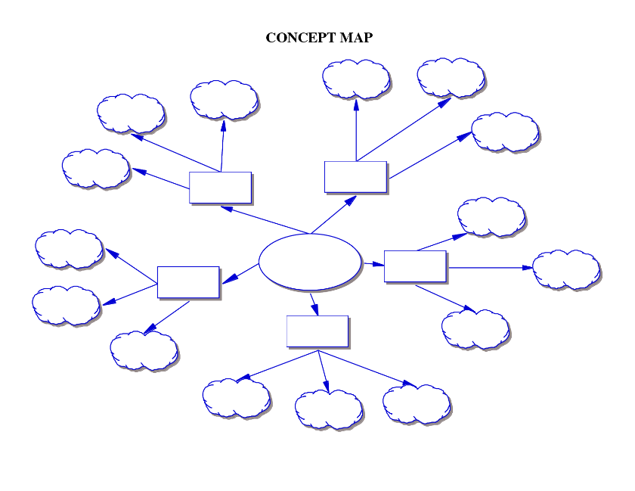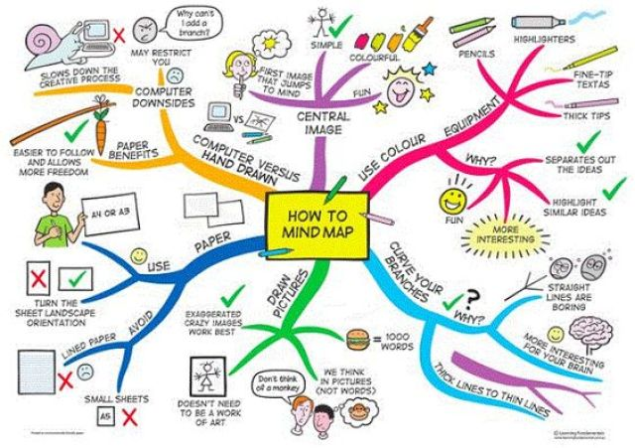Use the example mind map below to help create your own dyslexia mind map. Tailor it to your personal study needs by using pictures, images and colour to help you make it visual. Good luck!

**Tips on How to Revise**

What follows is a series of hints and strategies which may or may not be useful.

Do NOT use every method described here – this is like a Pick ’n’ Mix: try what you think will work for you.

**Active Revision**

Practice does not make perfect – perfect practice makes perfect. Face facts – browsing through your notes does not imprint vital facts into memory.

* You are not using your brain.
* It’s boring and sleepy
* It doesn’t fix things in your brain
* After, you don’t know whether you’ve learnt anything

For example:

* Have lots of scrap paper handy
* ****Study a topic e.g. how aerobic respiration works
* Try to memorise the crucial points
* Cover your notes
* From memory, jot down those crucial points
* Look back at your notes – did you get it right?
* Go over anything that’s wrong
* Use the traffic light system to check your progress

**Revise Your Revision**

Do not learn a topic and then leave it. Go back to it. Revisit it. It’s like that rugby/basketball/surfing/whatever skill – you need to OVERLEARN.

**The Best Way To Learn**

Apparently, you remember:

• 20% of what you read

• 30% of what you hear

• 40% of what you see

• 50% of what you say

• 60% of what you do

• 90% of what you read, hear, see, say and do.

Use lots of different approaches to reinforce your learning.

**Multi-Sensory Techniques**

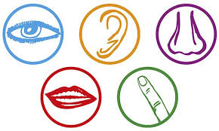

I said earlier about how we best remember when we combine saying, reading, hearing, doing etc.

The greater use you can make of your senses as you revise the better the recall, so here are some ideas:

• Make use of colour coding as much as possible – a set of highlighters are a must.

• RECORD YOUR NOTES AND PLAY THEM BACK – AN EXCELLENT IDEA.

• Watch dvd and tv programmes linked to your subjects.

• When you are revising, read the stuff OUT ALOUD.

• Walk around during revision – don’t sit still.

• Even PERFORM your notes, as in a play – anything which makes them stand out in your memory. Go over-the-top with it.

• Teach the material to someone as a lesson – or do it to yourself – but do it aloud.

• Prepare a powerpoint presentation on the material.

• Get someone to test you.

• You test them as well – thinking of questions is a good way to revise!

• Play different types of music for different topics or subjects. When you get stuck in an exam, relax and think of the music for the topic, and that might trigger your memory.

**Dyslexia YouTube videos**

* How to make a Mind Map

<https://www.youtube.com/watch?v=wLWV0XN7K1g>

* Dyslexia resources i.e. overlays, coloured paper

[www.crossboweducation.com](http://www.crossboweducation.com)

* Dyslexia explained: What It’s Like Being Dyslexic

<https://www.youtube.com/watch?v=IEpBujdee8M>

* The Power of Dyslexia

<https://www.youtube.com/watch?v=l_qGJ9svUbM>

* Famous people with dyslexia

<https://www.youtube.com/watch?v=nfBxDPQjoG4>

* Orlando Bloom and dyslexia

<https://www.youtube.com/watch?v=hLTSPmoH2eE>

* Dyslexia: Behind the news

<https://www.youtube.com/watch?v=EoCOj-6aPVU>

* Embracing Dyslexia

<https://www.youtube.com/watch?v=Vy5WxLf-r6g>

* Dyslexic Kids – Cover my eyes

<http://dyslexic-kids.tumblr.com/page/68>

Dyslexia Internet Sites

* Dyslexia Scotland

https://www.dyslexiascotland.org.uk/

* Dyslexia Unwrapped

[http://www.unwrapped.dyslexiascotland.org.uk](http://www.unwrapped.dyslexiascotland.org.uk/)

* History of dyslexia – timeline and information

<http://en.wikipedia.org/wiki/History_of_developmental_dyslexia>

* History of dyslexia

<http://www.dyslexiasw.com/advice/all-about-dyslexia/history-of-dyslexia>