Recruitment & Skills Centre | 11.02.2019

RSC Weekly Bulletin

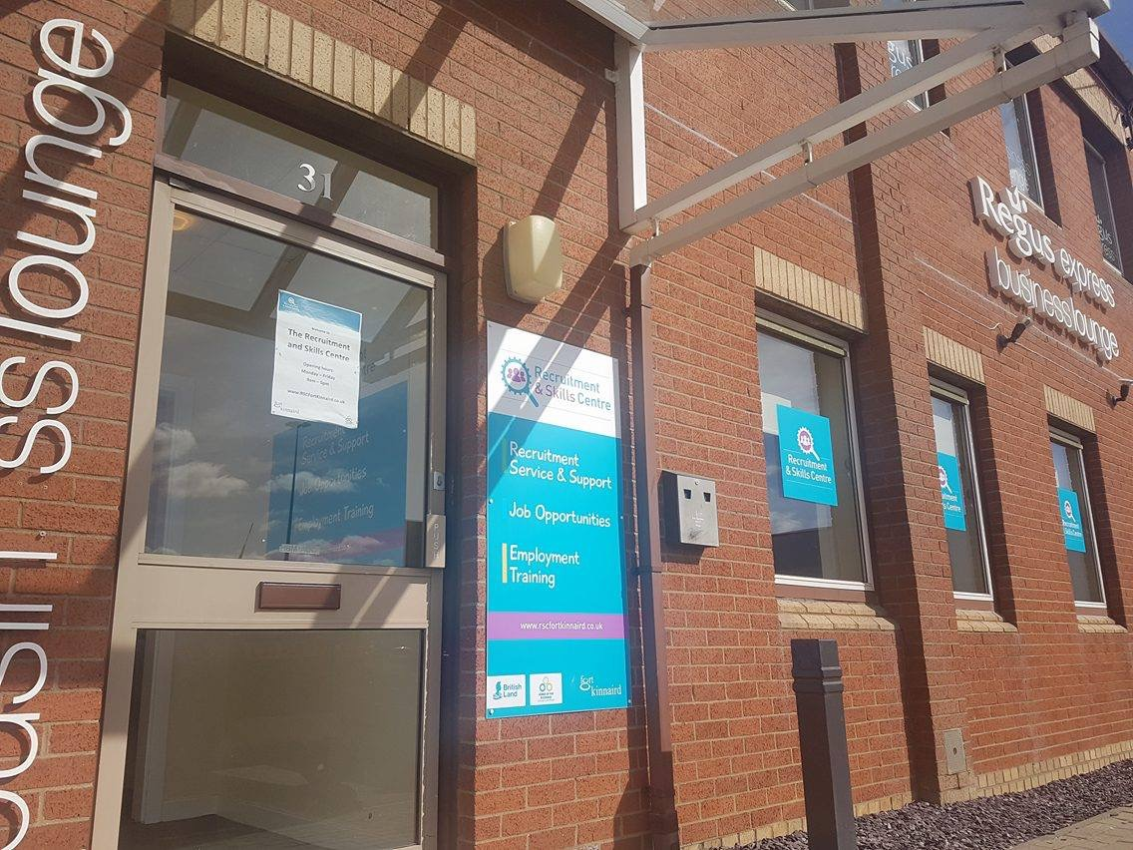

RecruitmentSkillsCentreFortKinnaird

@RSCFortKinnaird

Vacancies are also available on our website: www.rscfortkinnaird.co.uk
Join us on social media for daily vacancy updates:

VACANCIES
Argyle Bridge Children’s Nursery looking for a Level 3 Qualified Nursery Practitioner

Hours: Full Time
Wages: TBA

About Us:

Argyle Bridge Children’s Nursery is totally committed to providing exceptional care that helps young children to develop and give parents peace of mind and support. We recognise that our staff are our most valuable asset in ensuring that every Argyle Bridge Children’s Nursery child is a unique and happy child: healthy, social, confident, creative, independent and ready to learn.

We are looking for a Nursery Practitioner/Early Years Educator who shares our values to join our friendly team. You will be a Level 3 Qualified Practitioner who has passion and enthusiasm to complement our existing team of experienced child care practitioners.

About our Nursery

We believe children learn as they play and will learn better if they feel safe and secure in their surroundings. All our staff are fully qualified with a couple of trainees who are working towards a relevant qualification in childcare and education. We have monthly in-house meeting and training.

Key responsibilities:

Deliver rich learning opportunities and exceptional care that helps young children to develop
Plan and provide effective care, teaching and learning that enables children to progress and prepares them for school
Safeguard and promote the health, safety and welfare of children
Work in partnership with colleagues, parents and/or carers or other professionals to meet the individual needs of the children
Make accurate and effective use of assessment reflecting the needs, interests and stages of development of the individual children.
Provision of pension scheme auto enrolment is available

Job Type: Full-time
Experience:
Childcare: 2 years (Preferred)

If interested please send your CV to helen@abc45nursery.co.uk

Outfit, Fort Kinnaird, are looking to recruit Part Time Sales Assistants

Contract: 12 hours per week
Competitive hourly rate and benefits
Must be flexible to work evenings up to 10pm and weekend shifts between the hours of Sat 9am-6.30pm, Sun 8am-6.30pm
Our Sales Assistants are fundamental to our business; they are the face of OUTFIT and therefore must be passionate, energetic, provide excellent customer service and must love fashion!
Sales Assistants support our stores in maximising profit and achieving sales targets by showing a passion for customer service and ensuring customers leave with a lasting, positive impression of OUTFIT.
Staff benefits on offer:
25% discount on Arcadia Brands
Generous clothing allowance (up to 4 times per year
Team incentives including Company paid activities, social events and prizes for high performing stores
28 days holiday allowance for full time staff (including bank holidays)
To apply, please forward your CV together with a covering letter to:
applications@rscfortkinnaird.co.uk

Schuh, Fort Kinnaird, are looking to recruit a Deputy Store Manager
Permanent Full-Time Contract
Competitive Salary
About the role
You’ll need to be driven, have the knowledge and experience that could give the Store Manager a run for their money, whilst building upon your super skills and learning from theirs, sharing in their passion because one day you might spread your wings and fly to your very own store. An optimistic and energetic presence is a major part of this role, as well as being able to take responsibility, be it on the shop floor or in the stockroom. Training staff or number crunching are just as important as it is to help deliver a flawless customer experience. We want someone with a little va va voom and who aspires to run their own store.
About the location
Away from the hustle and bustle of city centre life, come check out our store in Edinburgh Fort Kinnaird. We have a huge range of brands to suit all tastes including Nike, Converse, Vans and many more. Whether you’re a lover of trainers or looking for the perfect pair of heels, you’re sure to find something here at schuh.
To apply, please go to:
https://careers.schuh.co.uk/listings/store%20management/1/622/

Currys PC World, Fort Kinnaird, are looking to recruit part time Sales Consultants
Permanent Contract
Hours: 6-15 hours hours per week, with flexibility to work additional hours
Wage: £7.20 per hour for under 21’s, £7.90 per hour for aged 21 or over
Technology is transforming the world in extraordinary ways. If you’re passionate about the latest innovations, and about discovering how products can make a real difference to customers’ lives, then you can be part of shaping that transformation here at Dixons Carphone.
Working as a Sales Consultant in one of our Carphone Warehouse stores (known as Customer Consultant within the business), you’ll help our customers with whatever they need, asking questions and taking them through our products and services until they have what’s right for them.
We want you to be able to give customers the best possible advice. So we’ll make sure you get early exposure to tomorrow’s technology and will give you brilliant training to help you stay ahead of the game. The fact that we’re completely impartial and independent means you’ll be free to find customers things they genuinely want and need.
Expect lots of support and encouragement while you’re here. You’ll be working alongside people who love what they do and enjoy sharing their enthusiasm with everyone around them. You’ll also have limitless opportunities to explore – whether that means building up new areas of expertise or taking your career in a different direction, potentially even with another brand in the wider Dixons Carphone group.
So what are we looking for from you? Like us, you’ll put the customer first, always. Also like us, you’ll be happy embracing all kinds of change. Things move fast in our business – and you have to have the resilience and adaptability to keep moving forward with them.
Above all, you have to share our passion for achieving amazing things – for our customers, colleagues and ourselves.
Bring your passion, make amazing happen.
To apply, please go to:
https://careers.dixonscarphone.com/job/customer-consultant-carphone-warehouse-carphone-warehouse-edinburgh-kinnaird-retail-park-539

Currys PC World, Fort Kinnaird, are looking to recruit Warehouse Support Colleagues.
Permanent Contract
Hours: 15-30 hours per week, with flexibility to work additional hours
Wage: £7.20 per hour for under 21’s, £7.90 per hour for aged 21 or over
Technology is transforming the world in extraordinary ways. If you’re passionate about the latest innovations, and about discovering how products can make a real difference to customers’ lives, then you can be part of shaping that transformation here at Dixons Carphone.
Our support colleagues are the unsung heroes of the store, connecting everything together by getting key jobs done quickly and quietly, allowing the sales team to fully concentrate on our customers. As you’ll be regularly on the shop floor you can expect queries from customers too, you’ll also find yourself helping out in countless ways such as receiving and storing product deliveries, replenishing shelves, updating displays and working on the till – ensuring customers last contact with us is always a brilliant one.
We’ll ensure you’re fully trained up to perform your role and start realising your potential – there could be extraordinary things ahead , prove yourself and lots of different career paths could open up in the Dixons Carphone group. The rewards are pretty special too. We offer one of the best packages in retail, with benefits including holiday, pension scheme and great discounts.
What are we looking for from you? An enthusiastic approach combined with a high level of organisation and a genuine passion for helping each and every customer – you have to set yourself high standards when the pace is fast and the pressure is on.
Above all, you have to share our passion for achieving amazing things – for our customers, colleagues and ourselves.
Bring your passion, make amazing happen.
To apply, please go to:
https://careers.dixonscarphone.com/job/support-colleague-currys-pcw-edinburgh-kinnaird-3-1-l02862-17908

Caffe Nero
SHIFT LEADER (FULL-TIME)
Fort Kinnaird Shopping Park, Unit G, Kinnaird Park, Edinburgh EH15 3RD
HOURS: 35 HOURS (FULL TIME)
SALARY: £7.38 – £7.83 PER HOUR
At Caffè Nero, it’s the people that make us unique. That’s why we’re looking for warm, positive people who genuinely enjoy working with others.
As a Shift Leader, you’ll work 35 hours per week, so flexibility is key. You’ll also need to work extra hours to cover others at times, and enjoy working in a fun, demanding and fast-paced environment.
You need no prior experience to do well in this role. But you do need to
- Enjoy coaching and interacting with others
- Enjoy leading by example
- Aim for excellent coffee and service
- Use your initiative at work, every day
- Be resilient and determined to achieve results for your store
- Be ambitious and driven
- Speak good English
- Enjoy making a difference to someone’s day
- Be flexible with your working hours
- Be a UK Resident, with the relevant work permits and evidence.
In return, we will give you full training by our dedicated in store Maestros or our training team on everything from how to make an Espresso through to a decaf soya Latte! So industry experience isn’t essential.
Over 80% of our current Store Managers started out as Baristas and Shift Leaders. And with our ambitious growth plans to open around 50 stores in the UK each year, we’ll give you every opportunity to develop.
Because when you join us, you’re joining a family – be it your team, your regulars, your neighbourhood or the Caffè Nero network. We want you to nurture those relationships, to join us in building something special, and to have fun doing it.
That fun includes loads of year-round events, including our regular CN Club parties, Barista of the Year events & lots more.
If this all sounds right for you, then you may well be right for us. Send CV to applications@RSCFortKinnaird.co.uk

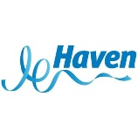

Seton Sands Holiday Park – Haven
Accommodation Team Member – Full Time and Part time
Do you want a career in the Accommodation team, working for The Times 6th Best
Big Company in the UK?
My Role as an Accommodation Cleaning Team Member is to consistently deliver
clean and well-maintained accommodation by ensuring quality, as judged by the
Customer, is at an optimum level.
The Purpose of the role:
•Relentless in delivering a high-quality accommodation experience for all our
Customers by following all trained Company processes and procedures.
•Support fellow Team Members in consistently delivering clean and well-maintained
accommodation.
•Role Model effective team-ship behaviours and our vision and values always.
•Deliver and embrace a park vision and strategy based on the commercial and
holiday maker needs on park.
•To deliver the very best guest experience embracing a &#39;breath of fresh air&#39; culture
with the holiday makers at the heart of everything we do.
•Through exceptional standards aiming to exceed our guest expectations to create
the very best impression of our park.
All our Team Members enjoy a fast paced and high-pressure environment, ensuring
that our holiday homes are presented to the highest quality to create the &#39;home from
home&#39; experience our holiday makers have grown to expect.
The Benefits of working with us:
•Free use of many of the Park facilities and discounts off our food and retail outlets.
•Discounted Bourne Leisure holidays for you, your family and friends.
•Reward and recognition schemes including long service and team member of the
month.
•Externally recognised qualifications to give you the opportunity to develop and
progress.
Our guests and our team members are vitally important to us and we need to ensure
we build effective relationships, through trust, always having an approachable,
friendly and helpful attitude. This will ensure our guests feel reassured that we
always have their interests at the heart of everything we do.
Interviews will be held on in Musselburgh Jobcentre North House, Eskmills
Park, Station Road, Musselburgh, EH21 7DU on Wednesday 13th February 2019
from 2pm to 4pm.
If interested call 0131 669 9883 to book an interview time. Bring your CV to the
interview.
Seton Sands – Haven
Front of House Vacancies
Do you want a career in the Food &amp; Beverage team, working for The Times 6th Best Big
Company in the UK?
As a Bar Team Member I am responsible for:
•Providing an outstanding Bar experience, ensuring great service, high quality products
offered and consistency in my approach.
•Offering a clean and safe environment for all.
•Ensuring all owners and holidaymakers know who to go to, and are given a warm welcome
and a first class service allowing a true &#39;escape from urban living&#39; experience.
•Creating and supporting a &#39;sense of community&#39; – a real family spirit.
•Recognise dissatisfaction and deal with complaints speedily and with empathy resulting in
customer satisfaction and improvement to the overall guest experience.
•Ensuring a robust knowledge of all products provided, identifying all secondary spend
opportunities and Bar experience improvements.
The Benefits of working with us:
•Free use of many of the Park facilities and discounts off our food and retail outlets.
•Discounted Bourne Leisure holidays for you, your family and friends.
•Reward and recognition schemes including long service and team member of the month.
•Externally recognised qualifications to give you the opportunity to develop and progress.
Our guests and our team members are vitally important to us and we need to ensure we build
effective relationships, through trust, always having an approachable, friendly and helpful
attitude. This will ensure our guests feel reassured that we always have their interests at the
heart of everything we do.
Interviews will be held on in Musselburgh Jobcentre North House, Eskmills
Park, Station Road, Musselburgh, EH21 7DU on Wednesday 13th February 2019
from 2pm to 4pm.
If interested call 0131 669 9883 to book an interview time. Bring your CV to the
interview.

OUTFIT, Fort Kinnaird, are looking to recruit Team Leaders.
The Job;
We have all types of Team Leader roles. Whether it’s driving the service on the floor or ensuring our stores look visually stunning, our Team Leaders set the standard that our Sales Advisors aspire to. They are fashion role models who show a real sense of pride in working for Topshop Topman.
Competitive hourly rate and benefits.
Permanent Contract: 36.5 hours per week.
Must be fully flexible to work shifts between the hours of 7.00am and 10.30pm.
Must Haves;
Experience at Team Leader level or equivalent.
Genuine love for the OUTFIT Brand with a knowledge of fashion.
Ability to inspire and motivate other team members in giving great service to our customers.
Strong knowledge of the local market place to understand the customer profile and also be aware of who the competitors are.
Ability to use the commercial tools available to make suggestions to the Manager identifying risks, and opportunities to maximise sales.
Strong planning and organisational skills with the ability to react quickly with changing priorities.
Confidence in communicating to the store team on a regular basis and give feedback where needed.
Proactive about self-development and supporting other team members in their development.
Our benefits include;
25% discount
60% uniform allowance
Excellent development programme
Customer service training
Holiday allowance
And much more

To apply, please forward your CV and covering letter to : applications@rscfortkinnaird.co.uk

ABM Enviro Team Cleaning Supervisor – Fort Kinnaird, Edinburgh

Full Time 37.5 hours per week – Salary £9.73 per hour

We are currently seeking to recruit a new member of the team. Fort Kinnaird are a world host recognised destination totalling over 800,000 sqft of prime retail. They are home to more than 60 of the UK’s leading Brands and have gone through an exciting refurbishment programme, additional restaurants and an Odeon cinema have been added to further enhance the Customer experience. Fort Kinnaird are ranked number 2 in the UK in terms of retail attractiveness and have further plans to develop the centre. With this in mind we are looking to recruit a customer focused supervisor to lead the team. Experience and a desire to deliver outstanding standards throughout the key areas of the centre are paramount, these include cleaning, maintenance and landscaping. Our ideal candidate will have experience at working in an outdoor environment and have a strong background in this industry. Critical to the role is a can do customer focused approach.

Duties will include:

To ensure that all team members carry out their cleaning duties in a correct and timely manner in accordance with the site cleaning specification.‬‬‬
To assist in delivering world class training to the team,
To carry out cleaning assignment responsibilities as designated by their Line Manager.‬‬‬
To be responsible and accountable for the basic training, motivation, discipline, safety and welfare of team members.‬‬‬
Conduct quality audits to ensure service delivery adheres to the requirements of the company and that standards exceeds client requirements.‬‬‬
To liaise with their Line Manager, Site Management and team members on a daily basis so that a sound communication channel exists so that team goals can be achieved.‬‬‬
Maintenance and correct / safe usage of all equipment on site ensuring any faults are reported and resolved as a matter of priority.‬‬‬
Ensure correct usage of cleaning chemicals ensuring minimal waste and sufficient stocks are always maintained.
To make sure that all team members are familiar with and adhere to the Company’s Health and Safety Policy and Procedures.
Ensure welfare needs of all team members are addressed in a promptly and effectively.
Complete HR issues for the staff under your control as agreed with Line Manager.
Maintain and foster excellent working relationships with the client and other stakeholders on site.
Qualifications and Experience

Previous industry experience in a similar role is essential‬‬‬
Good written and communication skills
Ability to get on well with others and inspire respect and confidence‬‬‬
Well organized with an attention to detail‬‬‬
Flexible / supportive team player‬‬‬
‬‬‬
An immediate start is available with this position.
Job Type: Full-time, 37.5 hours per week
Salary: £9.73 /hour‬‬‬
Job Location: Fort Kinnaird Shopping Centre, Edinburgh‬‬‬
Required education: High school or equivalent
To apply please send a CV to applications@RSCFortKinnaird.co.uk

