

Dalkeith High School

Maths

National 4

Added Value

Revision Booklet

**Contents**

**Practice Paper A (Pegasys) Part 1**

**Part 2**

**Answers**

**Practice Paper B (Pegasys) Part 1**

**Part 2**

**Answers**

**Practice Paper C Part 1**

**Part 2**

**Answers**

**Practice Paper D Part 1**

**Part 2**

**Answers**

**Queen Anne HS Revision Questions**

**National 4 Added Value Unit Practice Paper C Part 1**

**1.** 70% of the pupils in S3 went on the school trip to a theme park.

If there are 300 pupils in S3, how many went on the trip?

2. Using a scale factor of $\frac{7}{4}$, a pupil enlarged shape 1 to give shape 2.

Have they completed the enlargement correctly?

Give a reason for your answer.

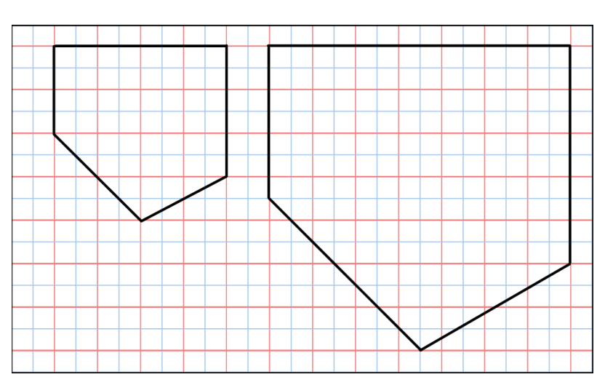

2

1

**3.** A book has 560 pages. Jason has read  of it.  
 How many pages has Jason read?

**4.** To make a fruit punch 2·75 litres of orange juice was mixed with 1·56 litres of pineapple juice. At a party 3·47 litres of punch was used.

How much was not used?

**5.** A group of 36 pupils were given the choice of playing either football, rugby or tennis.

Their choices are shown in the pie chart below.

How many chose to play tennis?

tennis

200°

rugby

football

120º

**National 4 Added Value Unit Practice Paper C Part 2**

**You may use a calculator.**

**1.** Solve algebraically the equation 7*x* – 5 = 3*x* + 13

34∙6cm

**2.**

A small door is rectangular with a semi circular window cut out from it.

26cm

3cm

The rectangle measures 34∙6cm by 90cm and the semicircle has diameter 26cm.

90cm

Calculate the area of wood required to make the door.

[i.e. the shaded area in the diagram] [Use π = 3∙14]

The ‘Shoe Tidy’ shown opposite   
is made up from wall brackets   
and pouches.

**3.**

pouch

wall bracket

**(a)** Copy and complete the following table.

|  |  |  |  |  |  |
| --- | --- | --- | --- | --- | --- |
| Number of wall brackets (*w*) | 2 | 3 | 4 | 5 | 6 |
| Number of pouches (*p*) | 3 | 6 |  |  |  |

**(b)** Write down a formula for calculating the number of pouches (*p*) when you know the number of wall brackets (*w*).

**(c)** If there are 42 pouches, how many wall brackets would be needed?

**4.** Darren left home at 11.55am and arrived at his destination at 2.10pm. He travelled at an average speed of 60 miles per hour. How far did he travel?

**5.** A special stage is being built for an outdoor concert. It has to be 30 metres wide, 1·5 metres high and have a ramp on one side

30m

37·5m

1·5m

Special non-slip matting has to be laid along the ramp.

The cost of the matting is £34 a metre and it is sold in complete metres.

Calculate the cost of the matting.

**6.** Steve wants to find the height of a building near his home. He stands at a point 25 m from the bottom of the building and measures the angle to the top of it to be 52o. The height to Steve's eye level is 1∙5 metres.

25m

52o

*h* m

1·5 m

Calculate the height, *h* m, of the building.

**7.** The weight of ten babies is shown in the table below.

|  |  |
| --- | --- |
| Age of baby (in weeks) | Weight of baby ( in Kg) |
| 4 | 3 |
| 7 | 5 |
| 2 | 3.5 |
| 12 | 4.5 |
| 9 | 4.5 |
| 1 | 3 |
| 6 | 4 |
| 12 | 5.5 |
| 5 | 4 |
| 10 | 5 |

1. Draw a scattergraph using these results (copy the grid below)
2. Draw a line of best fit for the scattergraph.
3. Mrs Brown’s baby weighs 4 kg at 8 weeeks old. She is concerned that her baby should be weighing more at this age. Is she correct?

Age of baby ( in weeks)

Weight of baby (in kg)

1



2

3

4

5

6

7

8

9

10

11

12

0

1

2

3

4

5

8. To win a prize at the school fair, you need to pick a red counter from a bag of counters.

In bag 1 there are 5 red counters and 20 blue counters.

In bag 2 there are 8 red counters and 34 blue counters.

Sarah thinks she has a better chance if she picks a counter from bag 2.

Is she correct? You must justify your answer.

**National 4 Added Value Unit Practice Paper C**

|  |  |  |  |
| --- | --- | --- | --- |
| **Part 1** | **Points of Process or Accuracy** | **Expected responses** | |
| **1** | * Evidence of appropriate division and multiplication * Correct division * Correct multiplication | * Divide by 10 and multiply by 7 or equivalent * 30 * **210** | |
| **2** | * Evidence of checking scale   # correct conclusion | * eg.4 x 7/4 = 7   # **no as eg diagonal line should go through 7 boxes** | |
| **3** | * Evidence of division by 4 and multiplication by 3 * Divide by 4 correctly * Multiply by 3 correctly | * 560 ÷ 4 × 3 * 140 * **420** | |
| **4** | * Evidence of appropriate addition and subtraction * Correct addition   Correct subtraction | * 2·75 + 1·56 **–** 3·47 * 4·31   **0·84** | |
| **5** | # correct strategy   * Process angle * Interpret fraction * Process | # 360 –(200+120)   * 40º * 40/360 or equivalent * **1/9 of 36 = 4** | |
| **Part 2** | **Points of Process or Accuracy** | | **Expected responses** |
| **1** | * Correct gathering of *x* terms * Correct gathering of number terms * Correct solution | | * 4*x* or 18 * 4*x* = 18 * ***x* = 4·5** |
| **2** | * Finds area of rectangle * Correct radius of semi circle * Finds area of semi circle * Shaded area found   # Overall strategy | | * 90 × 34·6 = 3114 * 13 * 265·33 [using 3·14] * **2848·67 cm²** [accept any rounding]   # Evidence of composite area including finding radius of SC |
| **3(a)**  **(b)**  **(c)** | * Table completed * Evidence of multiplier * Correct formula   # equates to 42   * Solve | | * **9,12,15** * Evidence of × 3 * ***C* = 3*D* – 3**   # 3D – 3 =42   * **15** |
| **4** | * Correct time in hours * Correct use of formula * Correct calculation | | * 2·25 hours * 60 × 2·25 * **135 miles** |
| **5** | # Right – angled strategy   * Find length of base * Correct Pythagoras statement * Correct side * Correct cost | | # finds one other side using Pythagoras’ theorem then adds length and multiplies to find cost   * 7·5 * 1·5² + 7·5² * 7·6 [any rounding] * **£272** |
| **6** | * Know to use tangent ratio * State correct ratio * Calculate height and add 1·5 | | * tan *x*o * tan52o = (*h* – 1·5)/25 * **33·5 metres** |
| **7(a)**  **(b)**  **(c)** | * 5 points drawn on the grid * Last 5 points drawn * Valid line of best fit drawn * Correct conclusion | | * Points correctly plotted * Points correctly plotted * Valid line of best fit drawn * Conclusion must fit with the line of best fit |
| **8** | * Probability for bag 1 * Probability for bag 2 * # No with reason | | * P(red) = 5/25 * P(red) = 8/42   # **No as 0.19<0.2** |

**National 4 Added Value Unit Practice Paper D**  **Part 1**

**1.** The value of a car falls by 40% during the first year from being brand new.

If the value of a new car is £12500, by how much will its value fall after the first year?

2. Using a scale factor of 3/2 , a pupil enlarged shape 1 to give shape 2.

Have they completed the enlargement correctly? Give a reason for your answer.

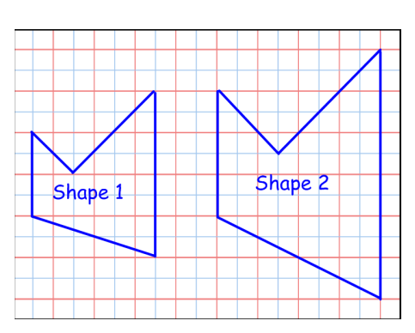

**3.** There are 234 people in the cinema.  of them are children.

How many children are there?

**4.** To feed some animals in the zoo 4·45kg of rice was mixed with 2·67kg of vegetables.

The animals ate 6·79kg of feed.

How much of the feed is left?

**5.**  A class voted for their favourite fruit.

The results of the 24 votes are shown below in the pie chart.

How many pupils voted for apple?

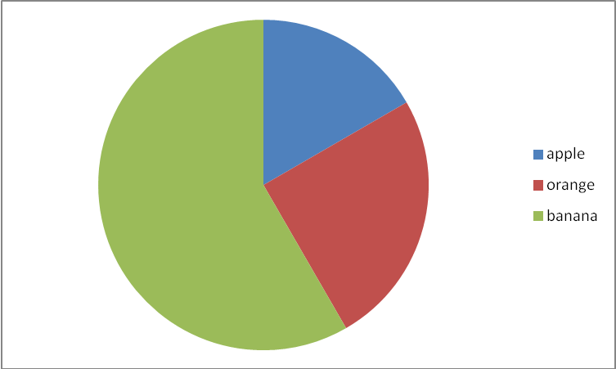

apple

banana

orange

90º

210°

**National 4 Added Value Unit Practice Paper D Part 2**

**You may use a calculator.**

**1.** Solve algebraically the equation 9*x* + 2 = 4*x* + 22

**2.** A worktop is made up from 2 pieces. The pieces are in the shape of a triangle and a rectangle.

0∙9 m

1∙4 m

2∙1 m

Calculate the total area of the worktop.

**3.** The design round the neck of a jumper is the like the one in the diagram.

1. Copy and complete the following table.

|  |  |  |  |  |  |
| --- | --- | --- | --- | --- | --- |
| Number of Diamonds (*D*) | 2 | 3 | 4 | 5 | 6 |
| Number of Circles (*C*) | 4 | 7 |  |  |  |

**(b)** Write down a formula for calculating the number of circles (*C*) when you know the number of diamonds (*D*).

**(c)** If there are 34 circles, how many diamonds were used?

**4.** Allan is training to run the London Marathon. He runs 18km each day at an average speed of 8 km/hr.

One day he started out at 0955. What time did he finish?

**5.** The Anderson Family have just built a sun room onto their house. The sidewall is glass and is in the shape of a rectangle and a right angled triangle.

4m

2⋅2m

3⋅2m

Calculate the perimeter of the wall.

**6**.A ramp has been constructed at a bowling club. It is 3⋅5metres long and rises through 0⋅5metres.

VICTORIA BOWLING CLUB

0⋅5m

3⋅5m

*x*o

Calculate the angle, *x*o, that the ramp makes with the horizontal.

**7.** A class of 10 pupils sat a Maths exam and a Physics exam.

Their results are

.

|  |  |
| --- | --- |
| Maths | Physics |
| 50 | 40 |
| 70 | 45 |
| 75 | 55 |
| 20 | 25 |
| 60 | 40 |
| 90 | 75 |
| 30 | 25 |
| 65 | 55 |
| 80 | 60 |
| 40 | 35 |

1. Draw a scattergraph using these results (copy the grid below)
2. Draw a line of best fit for the scattergraph.

20

20

40

40

60

60

80

80

100000

100000

Maths marks

Physics marks

1. One of the pupils scored 60 in his Physics exam. As he was absent for his Maths exam, the teacher estimated his mark at 60 also.

Do you agree with this estimate?



8. To win a prize, you must get a number greater than 4 when you roll a die.

In a different competition , you must get a number greater than 5 when you spin the octagonal spinner.

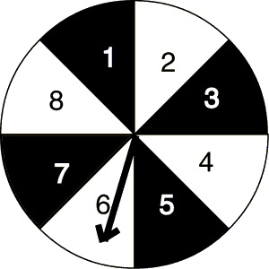

Jane thinks she has a better chance with the die.

Is she correct? You must give a reason for your answer

**National 4 Added Value Unit Practice Paper D**

|  |  |  |  |  |
| --- | --- | --- | --- | --- |
| **Part 1** | | **Points of Process or Accuracy** | | **Expected responses** |
| **1** | | * Evidence of appropriate division and multiplication * Correct division * Correct multiplication | | * Divide by 10 and multiply by 4 or equivalent * 1250 * **£5000** |
| **2** | | * Evidence of checking scale   # correct conclusion | | * eg.4 x 3/2 = 6   # **no as eg diagonal line should go through 6 boxes** |
| **3** | | * Evidence of division by 9 and multiplication by 4 * Divide by 9 correctly * Multiply by 4 correctly | | * 234 ÷ 9 × 4 * 26 * **104** |
| **4** | | * Evidence of appropriate addition and subtraction * Correct addition * Correct subtraction | | * 4·45 + 2·67 **–** 6·79 * 7·12 * **0·33** |
| **5** | | # correct strategy   * Process angle * Interpret fraction * Process | | # 360 –(210+90)   * 60º * 60/360 or equivalent * **1/6 of 24 = 4** |
| **Part 2** | **Points of Process or Accuracy** | | **Expected responses** | |
| **1** | * Correct gathering of *x* terms * Correct gathering of number terms * Correct solution | | * 5*x* or 20 * 5*x* = 20 * ***x* = 4** | |
| **2** | * Finds area of rectangle * Correct base of triangle * Finds area of triangle * Total area found   # Overall strategy | | * 0·9 × 1·4 = 1·26 * 1·2 * 0·84 * **2·1 m²** [accept any rounding]   # Evidence of composite area including finding base of triangle | |
| **3(a)**  **(b)**  **(c)** | * Table completed * Evidence of multiplier * Correct formula   # equates to 34   * Solve | | * **10, 13, 16** * Evidence of × 3 * ***C* = 3*D* – 2**   # 3D – 2 = 34   * **12** | |
| **4** | * Correct use of formula * Correct calculation * Correct time conversion * Adds on time | | * 18 ÷ 8 * 2·25hrs * 2 hours 15 mins * 1210 | |
| **5** | # Right – angled strategy   * Find height of triangle * Correct Pythagoras statement * Correct length * Correct perimeter | | # determines appropriate dimensions and uses Pythagoras’ theorem   * 1 m * 1² + 4² * 4·1 [any rounding] * **13·5 m** | |
| **6** | * Know to use sine ratio * State correct ratio * Calculate angle | | * sin *x*o * sin *x*o = 0·5/3·5 * **8·2o** | |
| **7(a)**  **(b)**  **(c)** | * 5 points drawn on the grid * Last 5 points drawn * Valid line of best fit drawn * Correct conclusion | | * Points correctly plotted * Points correctly plotted * Valid line of best fit drawn * Conclusion must fit with the line of best fit | |
| **8.** | * Probability for die * Probability for spinner   # No with reason | | * P(number>4) = 2/6 * P(number>5) = ⅜   # **No, as 0.333<0.375** | |