Confident Understood Inspired Kind Engaged Nurtured
Be Safe, Be Kind, Aim High

First Level Home Learning Grid – May 2021
Literacy  Reading  I am learning to read with increasing fluency and expression.  Try to read with a grown up or on your own every day. This could be a book you have from school or your own.  Before reading discuss the front cover and the blurb. Can you predict what the story might be about, what might happen?  When you have read a story or a chapter discuss with a grown up, or write down, your favourite part and why, favourite characters and why, what do you think might or could happen next?  Challenge – be a grammar detective. Can you spot verbs and adverbs in your story? Write them down and share them. (You might want to use some of these in your own story writing!)  Spelling  I am learning to spell common words using different strategies to help me.  Try some or all of these strategies to practise your spelling words.  1. Pyramid writing – write each spelling word in a pyramid  P  p y  p y r  p y r a  p y r a m  p y r a m i  p y r a m i d  2. Rainbow writing – write each word in rainbow colours e.g. r a i n b o w  3. Dots and dashes – split your words into sounds with dots under single sounds and dashes under special friends e.g.  dots dashes sounds  . . . . . . _ . . . _ . . .  4. Sentences – write an interesting sentence including your spelling words, can you write more than one of the words in each sentence?  5. Speed write – how many times can you write each word in 10 seconds? Can you beat that time?  OR how long does it take you to write each word 10 times? Can you beat your own time? | Literacy  Grammar  I am learning to identify and use verbs and adverbs.  A noun is a naming word, a thing such as table, boy, grass, school, aeroplane…  An adjective is a word that describes the noun, such as big, silly, beautiful, heavy, smelly…  A verb is a doing word, such as skipping, laughing, knitting, running, writing…  An adverb is a word that describes a verb, such as happily, quickly, carefully, neatly.  Spot the verbs and adverbs in these sentences…  The strong girl carefully lifted the heavy rock.  My class walked quickly and sensibly to the fire assembly point.  The boy kindly opened the door for his friend.  Now find the verbs and adverbs in these sentences…  1. The lights in the stadium were shining brightly.  2. I very quickly ran to catch the bus.  3. She was cautiously walking over the wobbly bridge.  4. My robot loudly beeped while it zoomed across the floor.  Writing  I am learning to create an interesting character for a story.  Create an interesting character, this could be a dragon, animal, pirate, princess, unicorn, troll, monster, alien, bug….  Draw a detailed picture of your character and then label the picture by writing information around it to describe them e.g. eye colour, prickly back, 4 long legs, hairy toes, brown hair…  After that write some words which describe what your character is like – happy, angry, kind, grumpy, smart….  Challenge – now use the character you have described to write a story about them.  Remember to include where, when, who (your character as well as maybe others) and what (the plot, what happens in the story?)  Try to use some adverbs in your story!  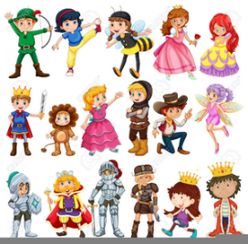 | Numeracy  I am learning to add, subtract, multiply and divide.  Every day do 10 sums to practice addition and subtraction. Do some mentally as well as written down. Try some different strategies to help you:  1. think about hundreds, tens and ones when adding and subtracting. Maybe draw them to help. Write the sums as a chimney sum.  2. use a number line, ruler or 100 square to count on when adding or back when subtracting.  3. count on by popping the largest number in your head and counting on, maybe use fingers to help.  4. near doubles – if the numbers are close, double the smallest then add on the extra e.g. 22+23=45, double 22 (44) then add 1 more (45).  5. draw your sum – draw the 10s and 1s, add the ones and then the 10s and add together. Or draw 10s and 1s then cross out 10s then 1s you are subtracting, how many left?  6. counting up on fingers from smallest number to find the difference to subtract, e.g 28-22, 1 finger up each time you count up from 22 > 23, 24, 25, 26, 27, 28 = 6 fingers  So 28-22=6  7. add/subtract to nearest 10 first e.g 36+8=78 (36+4=40, 40+4=44 or 85-7, 85-5=80, 80-2=78)  See pictures of examples below.  Mild – numbers within 20  Spicy – numbers within 100  Hot – numbers within 1000  Practise multiplication facts. Write them down or say them out loud. Lay out counters, sweets or toys to show groups of, e.g. 3 groups of 5 sweets = 15 sweets.  Mild- Starting at 0 count in 2s, use a number line to help. Can you try to count in 5s?  Spicy - 2,5, 10 times tables, count in 2/5/10s.  Hot - 2,3,4,5,10 times tables.  Extra hot – 3,6,4,8 times tables, try some division too! (e.g. if 5x9=40 so 40÷5=9)  Make a game of loop cards –cut out approx. 10 cards, write start on one side of a card and a sum on the other side. Write the answer on another card, turn that card over and write the next sum and then that answer on the next card and so on until you reach the last card. Finish with a tick instead of a new question on the last card. Play the game by shuffling the cards and laying them on the table question sides down. Start with the first card that says start and turn over the correct answers until you reach the tick.  Find games on Topmarks: https://www.topmarks.co.uk/Search.aspx?q=times%20tables  Sumdog – you could also log in to Sumdog daily to practise your skills.  Maths  I am learning to measure capacity and weight.  Capacity is the measurement of the volume of liquids. This is usually recorded in millilitres (ml) and litres (l).  Weight is the measurement of solids - how light or heavy something is. This is usually measured in grams (g) or kilograms (kg) but can also be in pounds (lb) and ounces (oz) or for people stones.  Use objects around the house or garden to measure.  What different liquids do you have in your home?  Here are some ideas of activities…  CAPACITY: fill a sink or the bath with water and fill different sized and shaped containers. Which do you think holds the most/least amount of water? Pour these into a measuring jug and see how many ml they are – were you right? Can you use the measuring jug to measure out 100ml, 500ml and 1litre?  Measure out and pour 300ml into 3 different containers, does it look the same?  Challenge – can you cover the numbers on the jug and estimate pouring in 200ml and 750ml of water? Reveal the numbers and see how close you were.  WEIGHT: Find your favourite toy and draw a picture of it. Now find different objects which are lighter and heavier than it.  Find 6 objects and order them from lightest to heaviest.  If you have kitchen or bathroom scales, weigh your teddy or toy. How many grams does it weigh? Can you find anything else the same weight?  Look at 3 objects without picking them up, predict which is lightest and heaviest. Then feel or weight them, were you right?  Now use these skills to do some baking (see HWB task)
HWB  I am learning to keep my body fit and healthy doing short repeated exercises.  Try to do some exercise each day. This could be cosmic kids yoga on youtube, searching for ‘the body coach’ on youtube, just dance or jogging around your garden.  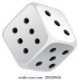  Here is another idea to keep active:  Roll a dice and match the number with an activity below. Roll the dice at least 6 times to do at least 6 of the activities, but try to challenge yourself to do more.  (if you don’t have a dice maybe use a spinner, online dice or spinner or write numbers 1-6 on small pieces of paper and lay them mixed up face down)  1 – 10 star jumps  2 – 5 ski jumps (feet together and jump side to side)  3 – 10 high knees ( jog on the spot lifting knees up to your chest as high as you can)  4 – 5 squats (stand with feet slightly apart and go to sit down pushing your bottom out but stand up again)  5 – sprint on the spot for 10 seconds  6 – 5 burst jumps (bend knees to crouch down to touch toes/floor then jump up reaching arms up)  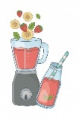  I am learning to use measuring skills to make healthy snacks.  Smoothies:  - 100ml full-fat milk  - 1 banana  - 150g frozen fruit of your choice  (or any fruit you have/like)  - 1 tsp honey  Put all in a blender and mix until smooth.  Flapjacks:  - 250g jumbo porridge oats  - 125g butter, plus extra for the tin  - 125g light brown sugar  - 30-40ml/2-3tbsp golden syrup (depending on how gooey you want it)  - Handful of dried fruit such as raisins, cranberries or half a mashed banana  Melt the butter and golden syrup. Add all the ingredients together and mix well.  Pour into a greased baking tray, pressing mixture down and into the corners. Bake in oven at 200c for approx. 15 minutes until golden brown. Cut into squares and leave to set. ENJOY! | Learning Across the Curriculum  Music  I am learning to create music using my body as percussion.  Watch this video…  https://www.youtube.com/watch?v=uzXpvILRMog  Now try to create your own body percussion music using these symbols (print them out or draw your own).  stamp clap snap  knee tap chest pause  There are examples below!  Art  I am learning to create objects using lines.  Use your imagination to be creative. Using simple lines try to create different objects using the circles worksheet.  Different lines you might use…  Art Challenge – Now use these lines and try to draw a farm landscape.  (Instructions below) | Learning Across the Curriculum  ICT  I am beginning to learn basic coding.  Scratch is a website we can use to start doing basic coding. Coding is used to make cartoons and games. Play about with Scratch and have a go at making your own scratch story.  https://scratch.mit.edu/projects/editor/?tutorial=getStarted  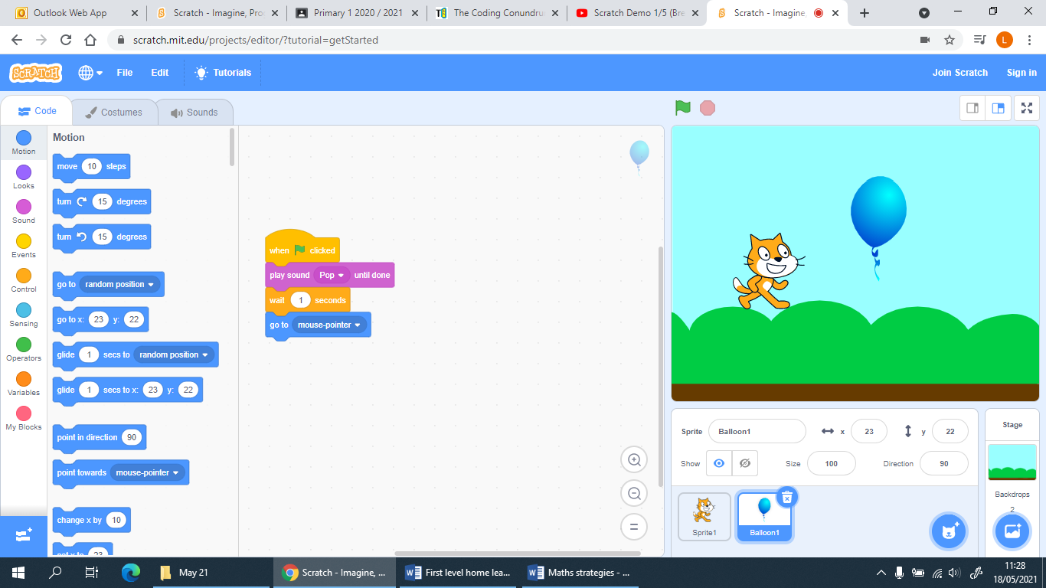  Use the video tutorials to help you…  Or here at https://www.youtube.com/watch?v=Jd58feIf8Zo  HAVE FUN AND SHARE YOUR CREATIONS ON GOOGLE CLASSROOM!  Science  I am learning how to grow a cress plant.  If possible ask a grown up to buy some cress seeds and plant some yourself. They don’t take long to grow, you can have fun creating cress heads and you can eat the cress once ready!  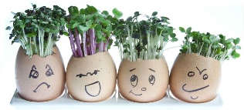  Instructions:  1. Decorate a small pot or cleaned out egg shell with a funny face.  2. Put some damp cotton wool or kitchen roll in the pot or egg shell.  3. Sprinkle some cress seeds and gently press them down, add a little more water.  4. Sit your cress on a window sill and watch the cress hair grow.  Remember to keep the cotton wool/kitchen roll wet.  Prediction experiment (worksheet below)  If you have enough, plant 4 pots. You are going to look after each pot differently.  Pot 1 - Place in sunlight and water regularly.  Pot 2 – Place out of sunlight and water regularly  Pot 3 – place in sunlight but do not water  Pot 4 – Place out of sunlight and do not water.  Predict which pot of cress you think will grow best.  What have you learnt that cress needs to live and grow?

Maths strategies
Using hundred, tens and ones…
Tens | Ones
3  + 2 | 6  2
= 5 | 8
Answer is 58

Hundreds | Tens | Ones
2  + 4 | 4  3  1 | 5  6
= 6 | 8  (4+3+1 tens) | 1  (write the one, carry ten over)
Answer is 681

Tens | Ones
3  - 2 | 6  2
= 1 | 4
Answer is 14

Blank one to help…
Hundreds | Tens | Ones
=

Use a number line or number square…
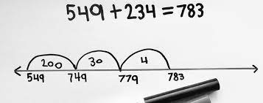
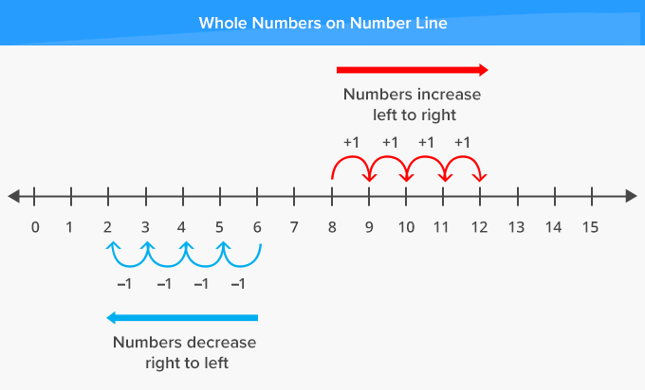
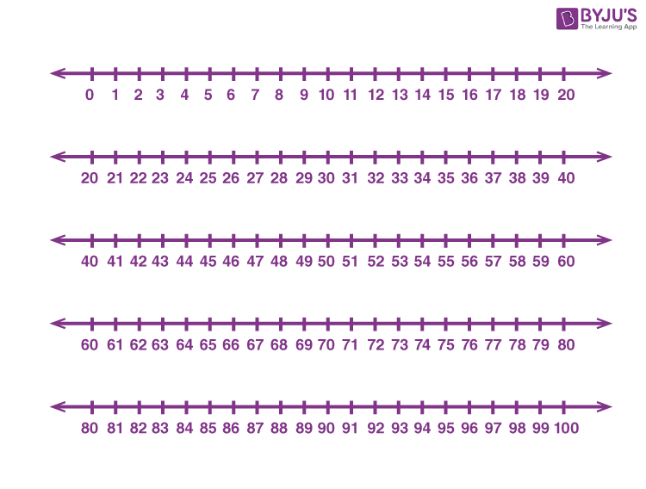
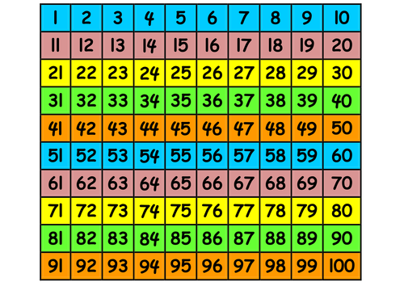

Use your fingers to count on and back
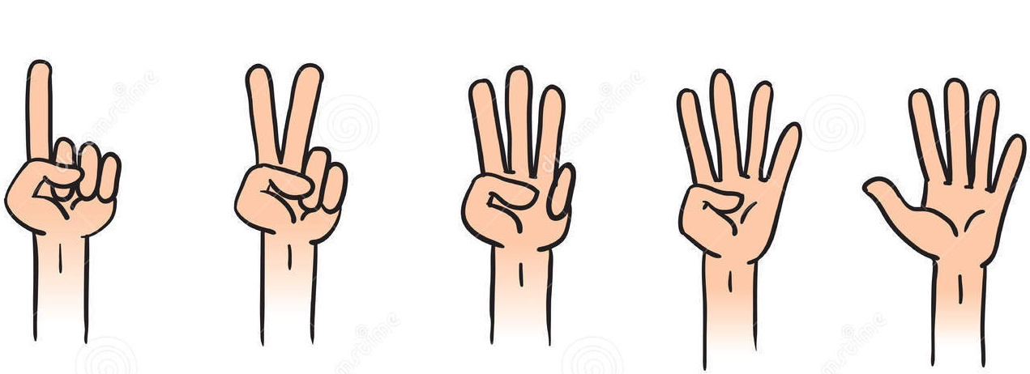
Draw your sums…

= 10 = 1

32 + 12 = 44

35 – 23 = 12

Body Percussion
stamp clap snap knee tap chest pause

e.g.
1.

2.

3.

Now make up your own…

Art

Science

