Literacy – Reading  Novel  I can use a front cover and blurb to predict what a book will be about.  This week we will be starting the novel “The Last Wild” written by Piers Torday.  A chapter will be shared on the Google Stream each day at 11am. This may be Miss Emsley reading or the Author.  Before you listen to any of the chapters, please complete your predictions first.  Look at the front cover:  - What do you feel when you look at the front cover?  - Who do you think the main characters could be?  - Read the blurb and identify any words which you feel are important to the story.  - Do you like the look of the book? Why or why not?  AR  I can read for information and  Enjoyment  Each day try to read at least 10- 20 minutes of a book and remember you can do your AR tests online but you need to follow the l to do so. Once you have followed the link you can bookmark it to use in the future.  World Book Day – 4th March 2021  Choose at least one of the activities below to celebrate World Book Day.  Listen to a free audiobook  If you choose to listen to one of the audiobooks please share in the stream what you chose to listen to and why.  Online Masterclass – create your own picture book theatre!  If you choose to create your own mini theatre please share pictures/videos in the stream so we can all enjoy your creation. | Literacy – Writing / Grammar  Informative Leaflet  Fair Trade Fortnight  I can organise information to educate others.  Continuing with our research of Fair Trade, I would like you to create a leaflet that can be used to educate others about the importance of Fair Trade.  I have included a template and an example leaflet to help you.  Success Criteria:  - I have included relevant and factual information about.  - I have used sub-headings to separate my information.  - My leaflet is eye-catching and clear to read.  Challenge:  - I have included a work bank with definitions.  Parts of Speech - Nouns, Adjectives and Verbs  Watch this video to help remind you of what a noun, adjective and verb are.  After complete the activities below.  Sorting nouns, adjectives and verbs.  Read the 30 different words and organise them into the correct category. Is it a noun, an adjective or a verb?  Using nouns, adjectives and verbs.  Create 5 sentences with at least one noun, one adjective and one verb in it. You can use the words you sorted or think of your own.  Challenge – Adverbs  Adverbs are words that describe verbs.  Using the 3 sentences can you identify the adverbs used? | Numeracy  Fractions and Percentages  Choose your task below or complete on Google Classroom.  Please watch the videos on Google Classroom to help you!  Mild  I can find a fraction of an amount where the numerator is more than one.  Spicy  I can find percentages of quantities  Hot  I can find any % of an amount using my knowledge of percentages  Sizzling  I can work out any % of an amount using my knowledge of percentages and decimals (eg 12% of 24 = 10% + 1% + 1%)  Sumdog  I can use digital technology to support and enhance my learning.  Log-on to Sumdog to take part in the Midlothian Maths Contest running from the 26th February – 4th March.  Try to practise for 20 minutes a day to help Cuiken Primary get to the top of the leader board!
Maths  Shape  Polygons are 2D shapes that are made of straight lines, and all lines in the shape connect.  Polygons can be regular or irregular.  A regular polygon has all angles equal and all sides equal.  A polygon without equal angles and side is known as irregular.  Find out about the different kinds of polygons here.  Polygon Picture  I can identify and draw 2D shapes.  Mild  I have created a shape picture with at least 5 different shapes.  Spicy  I have created a shape picture with at least 7 different shapes.  Hot  I have created a shape picture with at least 9 different shapes.  Online Games  Interactive Polygons  2D Shapes Sorting | HWB  PE  I can explore and choose movements to create and present dance.  Dancing is a fun way to carry out our daily physical activity.  Can you make a dance to a song you love, think about doing a different movement on each beat or create a pattern of movement.  Try to get your heart rate up while dancing, this may be achieved by doing bigger movements.  If you are feeling confident you could even film your dance and post it to Google Classroom for others to learn!  Health and Wellbeing  I know that we experience a variety of thoughts and feelings and I am learning ways of managing them.  It is important that we listen to our thoughts especially as they can tell us important information.  Sometimes thoughts can be difficult to manage when they are in our head as it can become overwhelming. Writing or drawing our thoughts can help our thoughts become clearer.  I have included example flow-charts to show what this might look like. Try to create your own using pictures or writing. | French  I can explore songs to learn new words in French.  Science Week! Les Science  Available from Monday 1st – Try some simple science experiments en français!  Available from Tuesday 2nd - – Take part in a French Bird ID challenge  Follow the link and click on the Les sciences playlist to access.  French Fridays!  Tune in on Friday at 11am to enjoy a free live French lesson!  This week Les sciences theme – learn a French song about the orbits, the sun, moon and earth!  The sessions are recorded so can also be watched afterwards.
Family Learning  Games  Spend time playing games as a family – this could be a dedicated games night or an activity during the day.  You might have a favourite game to play as a family but if not have a look at the suggestions below;  Hide and Seek  Pictionary  Charades  The Floor is Lava  Hotter or Colder  Simon Says  Fair Trade – Scavenger Hunt  In your house or if you go on your weekly shop with adults at home I would like you to look out for as many Fair Trade products as possible.  Look for;  Chocolate  Honey  Tea  Coffee  Fruits  The Fair Trade symbol is used to show if a product is Fair Trade. | Learning Across the Curriculum  Penicuik – Presentation  I can explore my local area and present information on interesting places to visit.  Find a local historical place in Penicuik – you may want to revisit the History and Heritage Trail to help you.  Create a poster or use technology to create a slide. You may choose more than one place to create a short presentation on.  There is a video attached demonstrating how to create a slide using images and transitions.  Remember you are trying to create a presentation that gives information about the history of Penicuik while making the audience want to visit.  Success Criteria:  My presentation (poster or slide) has…  - A title telling my audience what my information is about.  - At least 2 pieces of information on my chosen historical place in Penicuik.  - Colour and pictures to make it pleasing to look at.  - A clear layout to help the audience read my information  Challenge (slides)  - I have included a transition in my presentation.  Art – Landscape  Last week you were asked to look at a range of landscapes and observe what pictures you prefer and why.  This week we will use our knowledge to create our own landscape artwork of Penicuik.  For your landscape, it would be helpful to work from a photograph or a view that does not change as it may take you more than one day to complete.  Remember to consider;  What objects are in the background and foreground? How will you show this?  Where is the horizon line?  What colours will you use to bring your image to life? This will also determine if it is realistic or abstract.  Is there a main focus or feature of your landscape? | Learning Across the Curriculum  Fair Trade  I can identify the environmental impact of human activity.  As you may have found out last week, Fair Trade is important in helping people receive a better life through protected wages and improved working condition.  But what about the environment?  Guardians of the Rainforest  - Watch the short video (12 minutes)  - While watching listen for the answers to these 4 questions – you may need to pause the video.  1.What are the 3 risks that the rainforest faces?  2. What fair trade product does Beshey’s family grow?  3. Why is the rainforest important? (8 minutes 50)  4. How do the farmers protect the rainforest and the animals in it?  After you have answered the questions, choose 2 activities from the 8 choices.  Outdoor Learning  I can use natural materials to construct a model.  Last week, we looked at the journey of chocolate and you may have found out that most cocoa beans are produced in West Africa due to the climate.  In Scotland our climate is very different to West Africa and therefore we have different ecosystems. However, there is a bird that enjoys both climates… The Osprey.  The Osprey is a large fish-eating bird of prey. Ospreys migrate to West Africa for the winter, covering up to 5,000 km during their journey.  The nesting site at the Loch of Lowes Wildlife Reserve have been lucky enough to track these wonderful birds on their journey. You can watch the route and find out more on their website.  You can find out more about Ospreys here.  The Challenge: Recreate a small scale Osprey Nest using sticks and other natural materials. Your nest must be strong and secure!  Osprey nests are very large and can usually be located near the top of mature trees.  Their nests are large and it is important that the structure they choose can support the weight of the nest and the birds.  The nest at Loch of Lowes is about 1.8 metres wide and 60-90cm deep!! Each year that the bird returns to the nest they will rebuild to fix any damage caused over winter.

Complete each activity on the grid – these can be completed in Green Jotter you were given.

Novel – The Last Wild
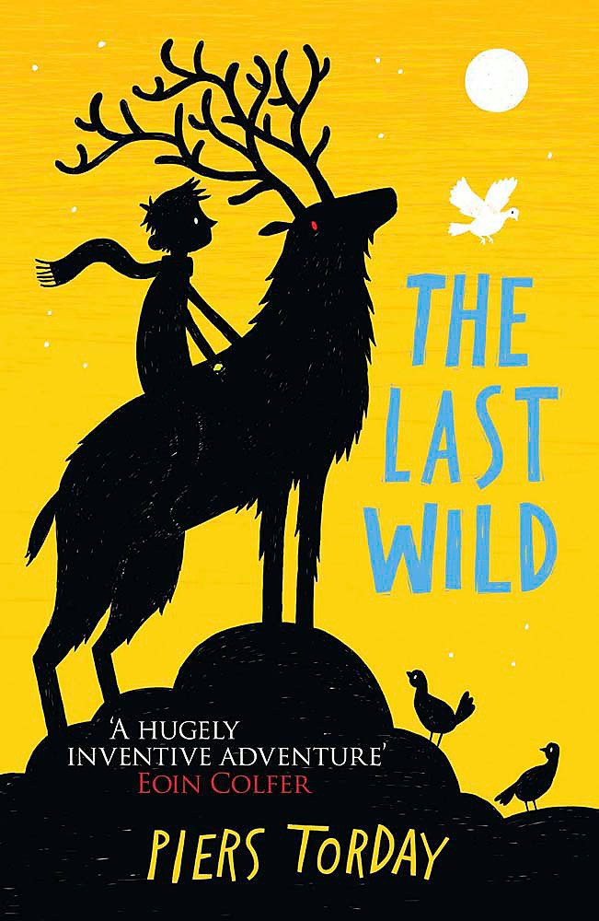

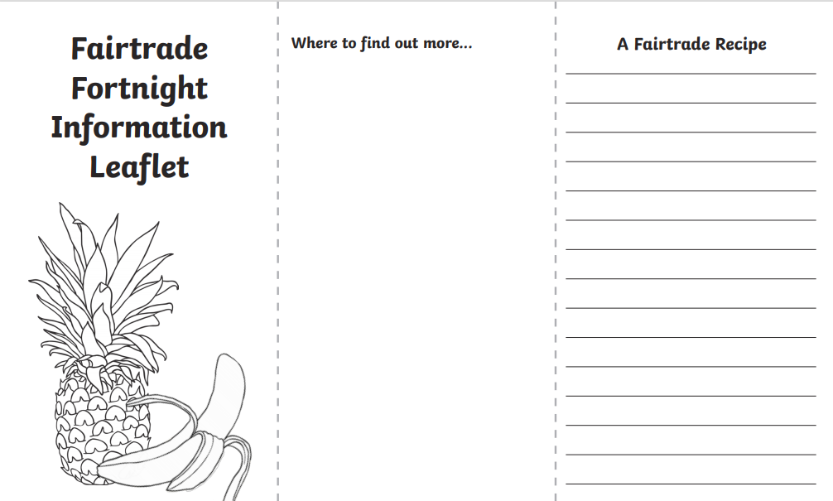
Fair Trade – Information Leaflet
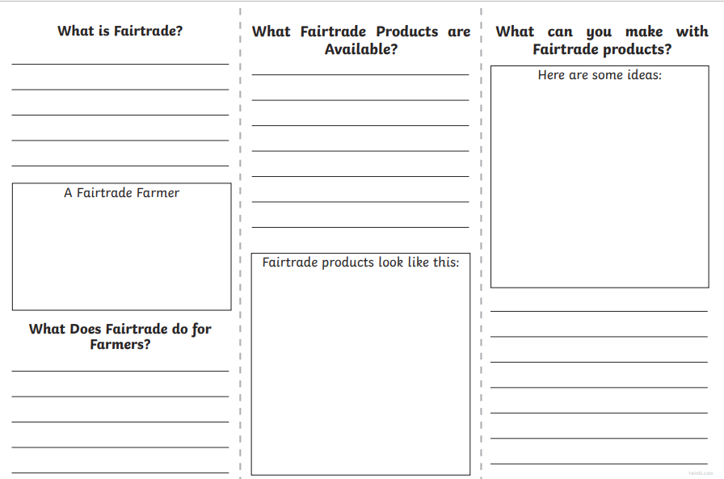

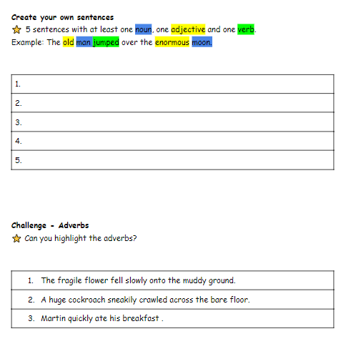
Parts of Speech
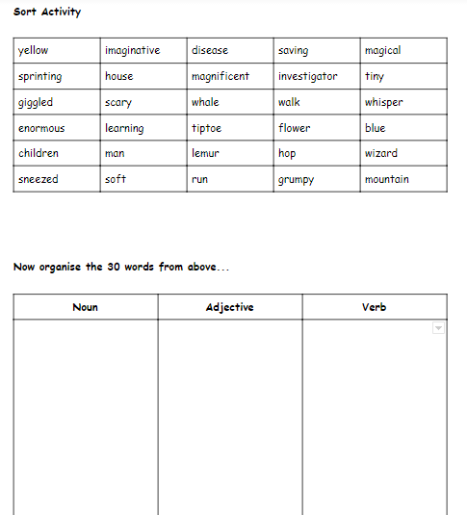

Numeracy

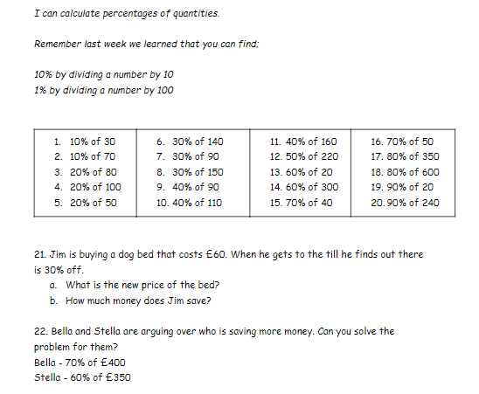
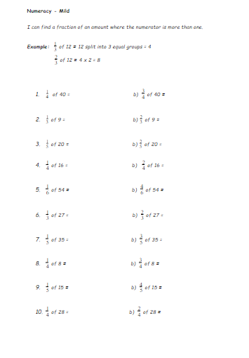
Mild Spicy

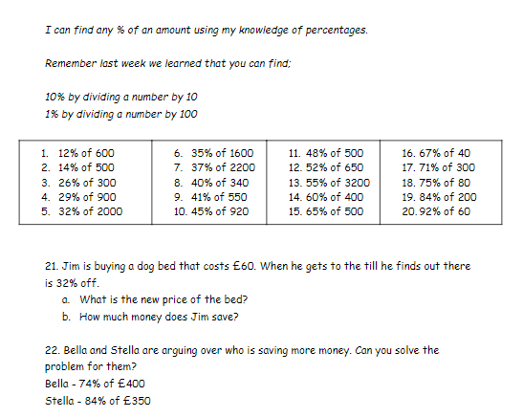
Hot Sizzling

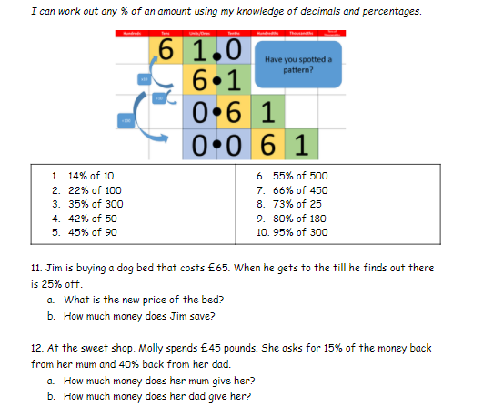

Maths

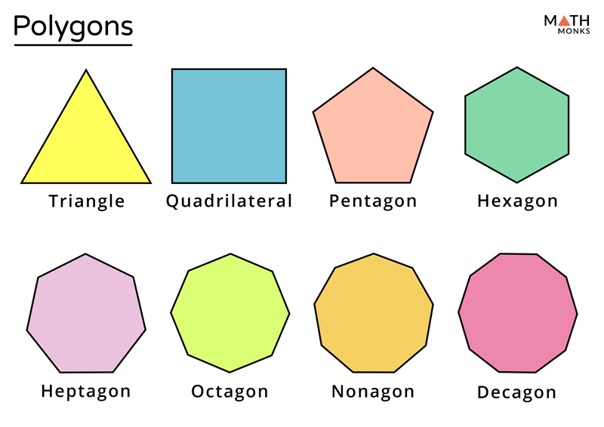

Maths Polygon Picture

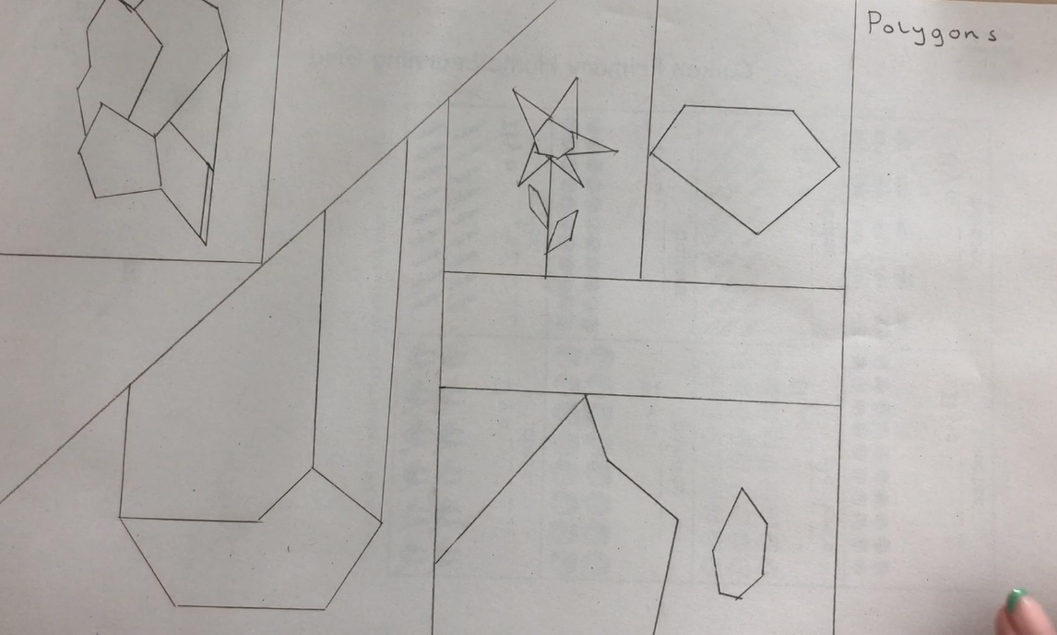

Health and Wellbeing
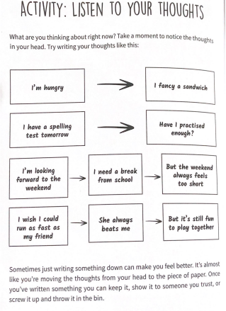
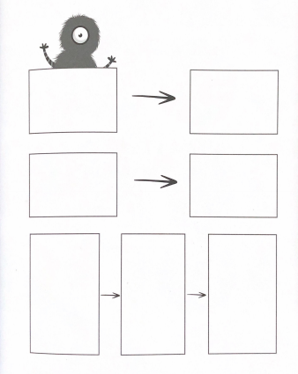

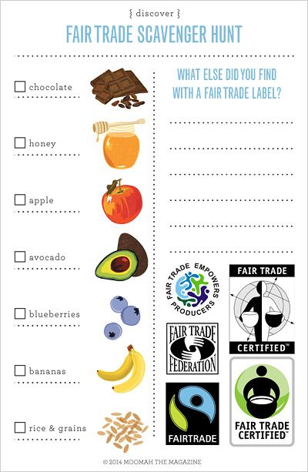
Family Learning
Games:
Pictionary – players take turns drawing a picture. The other plays need to guess this word with no other hints other than drawings.
Hotter or Colder – a searching game. One member of the house hides an object somewhere in a room (for example, a sock), the player must then use “hotter or colder” clues from the person who hid the object to find it.
The Floor is Lava – players must avoid sections of the floor which are lava using their problem solving skills.

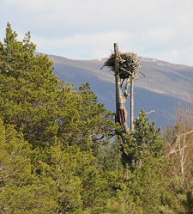
Outdoor Learning

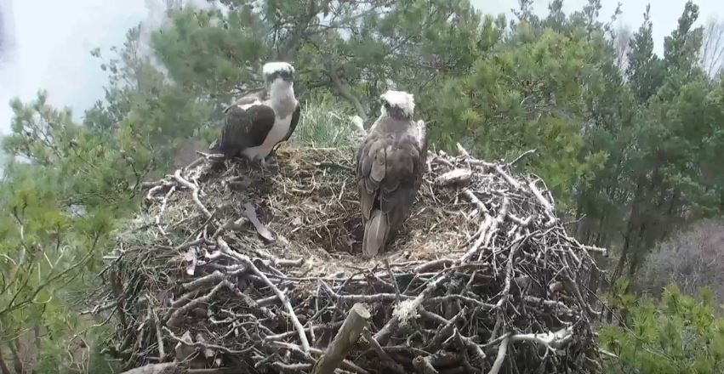

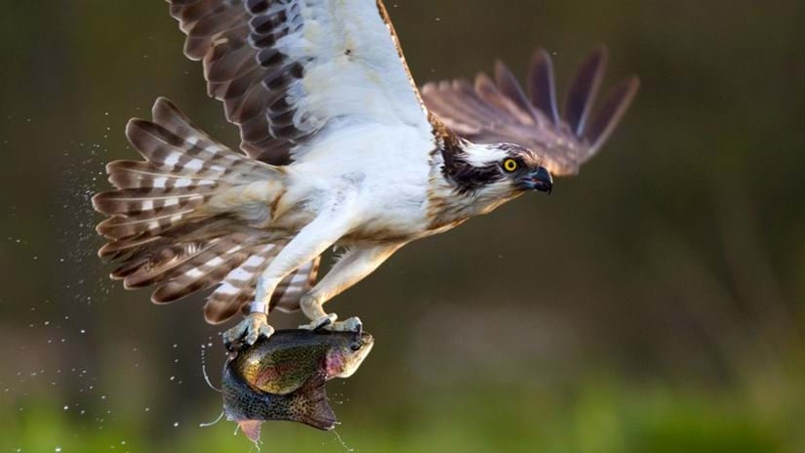
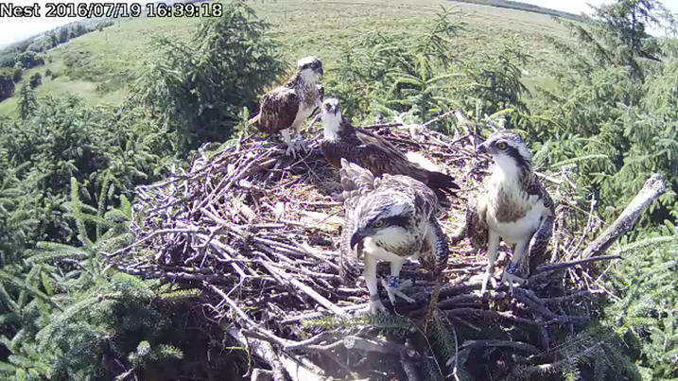

Penicuik

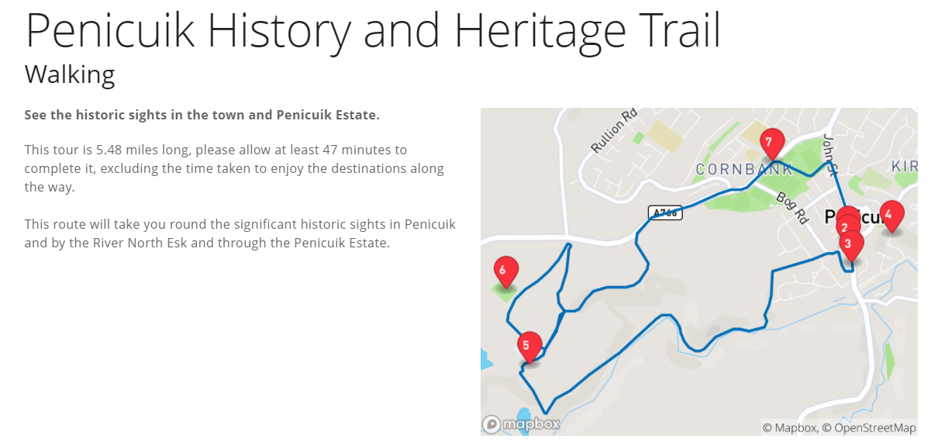

Fair Trade

