Confident Understood Inspired Kind Engaged Nurtured
Be Safe, Be Kind, Aim High

Cuiken Primary School

Nursery Class

Parent Information Handbook

Dear Parents and Carers

A warm welcome to our Nursery Class from all at Cuiken Primary School and Nursery.
Joining our nursery class is your child’s first important step in becoming part of our learning community and we will work to involve you and your child in the community life of the nursery. Throughout the year we have various activities, events and meetings which offer opportunities for your child to showcase their progress in learning and therefore, parental involvement is crucial.
We hope that this handbook will help you to understand more about our nursery, but also provide you with essential and interesting information. However, if you any further questions or queries please contact your Key Worker in the nursery. A member of the team will attend to your query/concern as soon as possible and if necessary, a follow up appointment with a member of the Management Team will be made.
At Cuiken we firmly believe that partnership between home and nursery is key to getting the best from our children. Therefore we have an ethos of treating each other equally with honesty and respect and these values are also encouraged with the children in the nursery too.
We look forward to building a positive relationship with you and your family at Cuiken Nursery.

Kimberley Hughes
Depute Head Teacher
Contents

 |  | Pages
Section One | Our Aims | 3
Section Two | General Information | 4 – 10
Section Three | Medical Information | 11 – 13
Section Four | The Nursery Curriculum | 14 – 19
Section Five | Parental Partnership | 20 – 21
Section Six | The Community | 22
Section Seven | Transitions | 23
Section Eight | Other Information | 24 - 25
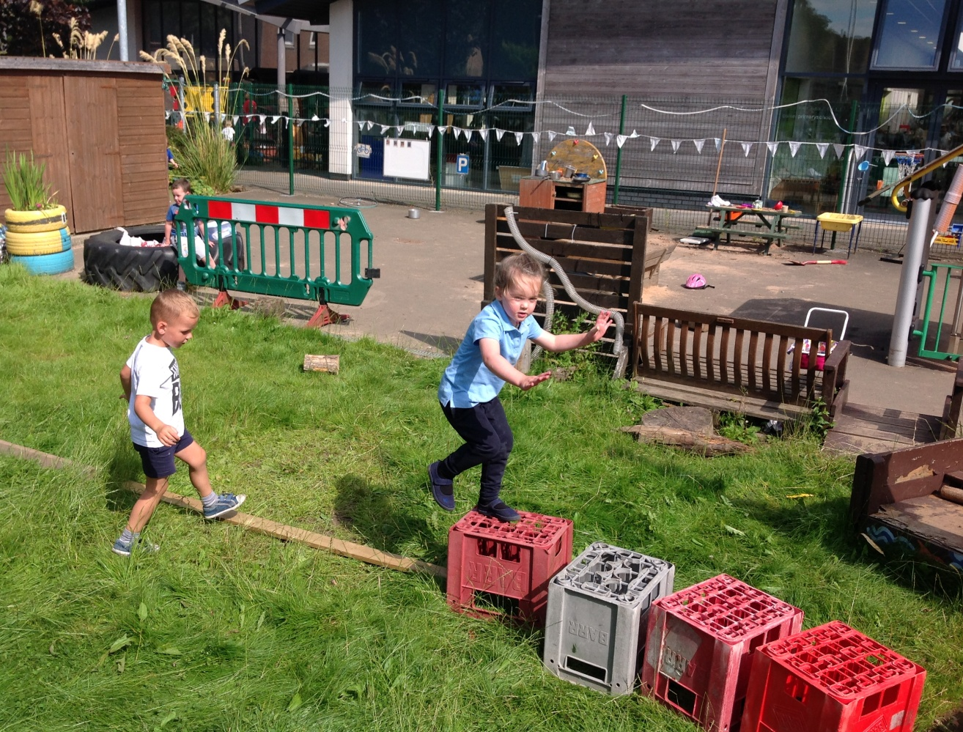

Our Nursery Class Aims
Our vision at Cuiken is for our learners to be...
- Confident
- Understood
- Inspired
- Kind
- Engaged
- Nurtured
Values
3 consistent rules underpinned by our values
- Be Safe
- Be Kind
- Aim High
In particular, we would like to note the following:
Non-denominational Policy of the Nursery
The nursery is non-denominational. We respect and welcome children and parents of all religions, faiths and beliefs.
Our Equal opportunities Policy
The nursery believes that children and staff have the right to learn and work in a caring and safe environment. As in all pre-five services, Cuiken Primary Nursery Class reflects the Council’s equal opportunities policies and recognises the rights of both men and women to work or care for our children. Provision takes account of the needs of children with additional support needs, whatever these may be. These principles are reflected in the criteria used to admit children to our nursery and in the curriculum of all Midlothian Council pre-five establishments.

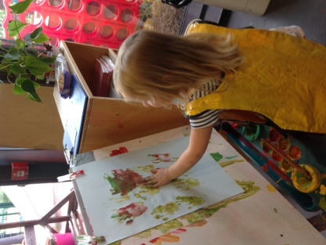
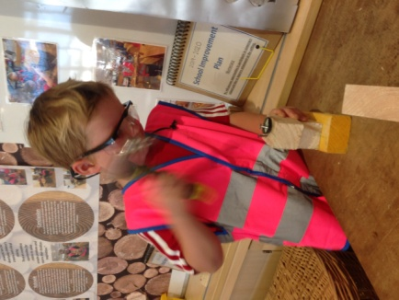
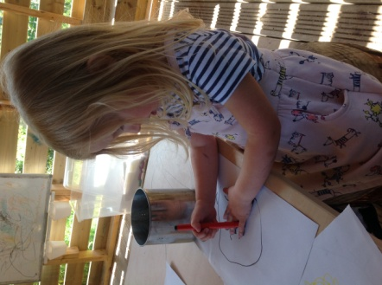
NURSERY CLASS INFORMATION

Name: Cuiken Primary School Nursery Class
Address: 150 Cuiken Terrace
Penicuik
EH26 0AH
Telephone: 0131 271 4580
E-Mail: cuiken_ps@midlothian.gov.uk
Web: http://cuiken.mgfl.net
The school’s nursery class provides 24 Full time spaces and 30/30 part time morning and afternoon places for children aged 3 to 5 years.
The nursery sessions are as follows:
Full time session
Monday to Thursday 8.15-3.45pm

Morning part time session
Monday to Friday 8.30 – 11.40am

Afternoon Session
Monday to Thursday 12.25 – 3.35pm
Friday Morning 8.30-11.40am

There are core hours during which children should be in the nursery.

In the mornings the core hours will be 8.50am – 11.20am and in the afternoons the core hours will be 12.45 – 3.15pm.

If collecting or dropping off children out with these times and the Nursery gate is locked please access using the school’s main entrance.
NB: Children are eligible for a funded nursery place from the beginning of the term following their third birthday.
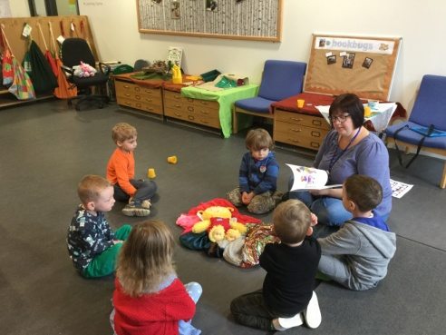
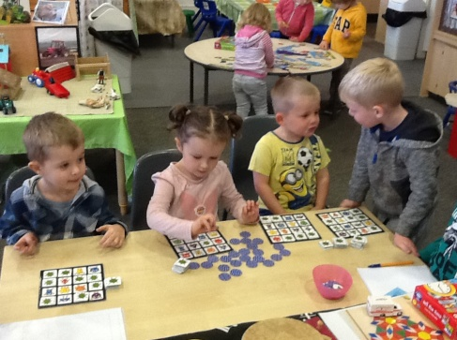
*Children should be collected promptly at the end of each session by a known adult.
 | Clare Bond | Head Teacher
 | Kimberley Hughes | Depute Head Teacher
 | Susan Dickson | Administration Assistant
 | Debbie McFarlane | Senior Child Care and Development Worker
 | Gem Barrett | Senior Child Care and Development Worker
 | Ann Affleck | Child Care and Development Worker
 | Pat Duncan | Child Care and Development Worker (AM Group only)
 | Laura Barfoot | Peripatetic Child Care and Development Worker
 | Lillian Wheater | Child Care and Development Worker
 | Rosie McCallum | Child Care and Development worker
OUR STAFF

HOLIDAY DATES
Term and holiday dates are intimated regularly to parents by means of newsletters, Midlothian Council and School websites. Relevant dates for this session are as follows:
MIDLOTHIAN COUNCIL SCHOOL

SESSION DATES 2019 /20

TERM 1 Staff Resume Thursday ** 15 August 2019
Pupils Resume Monday 19 August 2019

Mid Term Autumn Holiday Monday 16 September 2019
Staff Resume Tuesday* 17 September 2019
Pupils Resume Wednesday 18 September 2019
All Break Friday 11 October 2019
Staff Resume Monday** 21 October 2019
Pupils Resume Wednesday 23 October 2019
Term Ends Friday 20 December 2019

TERM 2 Staff Resume Monday* 6 January 2020
Pupils Resume Tuesday 7 January 2020

Mid Term All Break Friday 7 February 2020
All Resume Monday 17 February 2020
Term Ends Friday 3 April 2020
Good Friday 10th April
Easter Monday 13th April
All Resume Monday 20 April 2020

TERM 3 May Day Friday 8 May 2020
Victoria Day Monday* 18 May 2020
Term Ends Friday 26 June 2020

* Staff In-Service Days: Thursday 15th & Friday 16th August 2019,
Monday 21st October 2019, Monday 6th January 2020
& Monday 18th May 2020
Tuesday 17th September & Tuesday 22nd October
ADMISSIONS POLICY
All nursery places are allocated in line with Midlothian Council’s admissions policy and the Head Teacher or office staff will be happy to advise you how this policy operates when you apply for a place for your child. A leaflet detailing the Council’s policy is available from the nursery and the school office.
REGISTER OF APPLICANTS
A register of all applicants is held centrally by the Early Years Childcare Department and the information contained in the applications will be considered by the admissions panel where necessary to assist in the allocation of places.
Parents can ask to see their application form at any time. If circumstances change which affect the application you should speak to the Early Years Childcare Department who will in turn pass on your information to the Head Teacher.
ENROLMENT PROCEDURES
When you are allocated a place in our nursery class you will be informed by letter from Cuiken Primary School. We will advise you of an induction day where parents come in without children to complete paperwork and find out all about the nursery.
The Head Teacher will give you a starting date and details of the enrolment procedures.
ATTENDANCE
Although you are able to share a Nursery placement with a partner provider, your child must attend Cuiken Nursery for at least two sessions per week. This arrangement should be agreed when your child starts. Although attendance at Nursery is non statutory, you are asked that your child attends regularly. If your child is absent, it would be helpful to telephone within the first half hour of the session to let us know the reason for his/her absence.
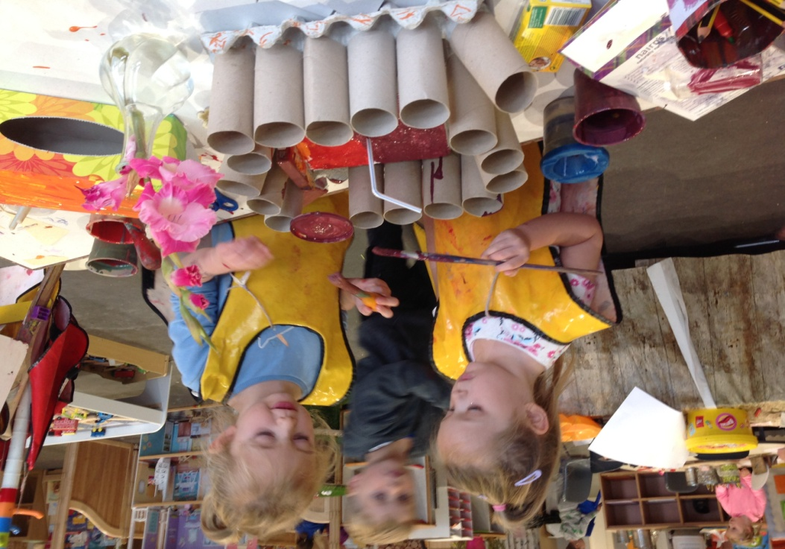

ARRIVAL AND COLLECTION OF CHILDREN
It is expected that a responsible adult (over the age of 16), will bring your child to and from the nursery. On arrival, your child will be welcomed individually as he or she enters the nursery by a member of our staff team. The arrival/departure is entered for each child in the official register, following self-registration by the child.
In the interest of your child’s safety, you should make a point of telling the member of staff if he/she is to be collected by someone other than yourself. This ensures that staff and children are aware of any changes. We operate a password system.
Parents’ notice boards are situated in the entrance area and provide information about events, any focus in learning and the daily snack menu.
SUITABLE CLOTHING
Children always have the best fun when they are doing messy work. We will always try to make sure they wear aprons but accidents happen! Please dress your child in suitable clothes. The children enjoy wearing the nursery sweatshirts as they are similar to those worn by the school children. These can be purchased through the School Office. Please also supply a change of clothing which your child can bring to Nursery daily.
Please ensure that all clothes are labelled as a number of children have the same or similar items of clothing or shoes. Your child should bring soft shoes to wear in the nursery. Please ensure your child has suitable clothing for outdoor play as we go out in all weathers; wellington boots in winter and hats in summer. In the summer months, please also make sure your child wears sun cream, staff will also apply sun cream for your child.
EXCURSIONS AND CONSENT FORMS
When outings or excursions are planned, you will be advised in advance. You will be asked to complete consent forms, which give your permission for your child’s participation. Please note that children cannot take part in outings unless completed consent forms have been submitted by their parent/carer.

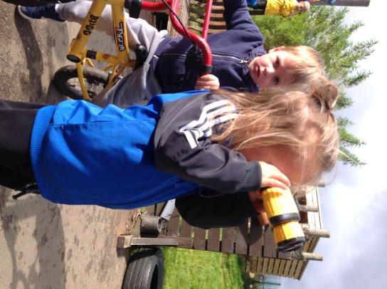
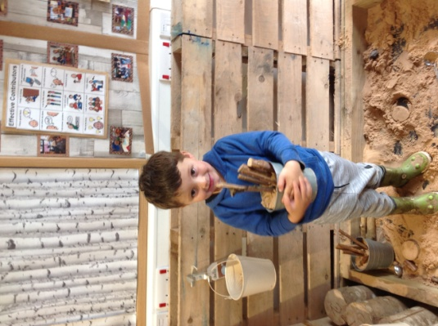

EMERGENCY CLOSURE ARRANGEMENTS
The nursery will be open at the times already outlined, but on some occasions circumstances arise which mean the nursery has to close.
Establishments may be affected by, for example, severe weather, transport problems, power failures or difficulties with fuel supplies. If this happens, we will do all we can to let you know about the details of closure and re-opening, via the school website, text or Parent mail (an email system used for newsletters, general announcements and events).
We will keep in touch be text, e-mail and/or announcements in the press and on Forth One .
EMERGENCY CONTACTS
Parents are asked to provide the staff with the names, addresses and telephone numbers of two contact persons for use in case of an emergency.
You are also asked to keep the nursery and school office up-to-date with any changes to this information.

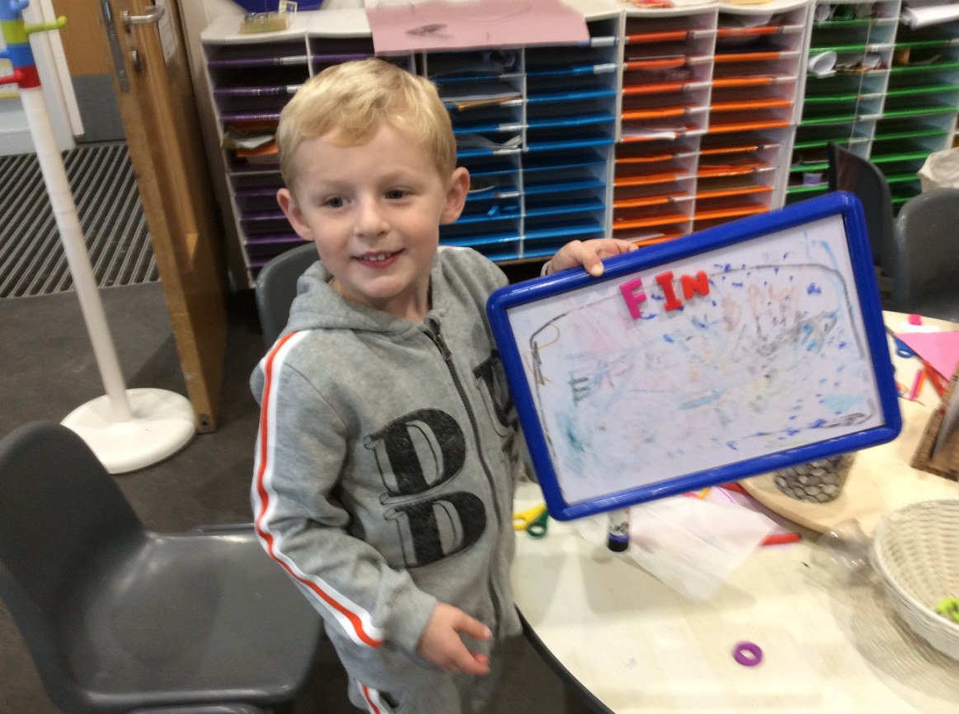

FULL TIME LUNCH
Children who are attending the nursery full time will be suppied with a lunch from the school kitchen. There is a hot and cold option each day and all dietry requirements are met.
SNACK AND THE PROMOTION OF HEALTHY EATING
We are keen to encourage healthy eating and so a snack of milk, fruit and vegetables will be offered to your child along with anything prepared or baked by the nursery children. Please do not let your child bring sweets, crisps, juice, chewing gum etc. to the nursery. Milk is provided free to nursery aged children. Snack and fund money is currently £2.00 per week for part time children and £3 a week for Full time. Snack and fund money are payable on a termly basis to the school office. If you would prefer to make weekly payments please speak to the school office. Fund money helps us with our day to day expenses and provides ‘extras’ for the children such as visits from theatre companies and outings in the minibus.
NO SMOKING POLICY
Smoking is not permitted in the nursery or in the surrounding environment. Parents are asked to respect this rule.
PHOTOGRAPHS / VIDEOS
Photographic and/or video recordings are made for educational purposes. On occasion, the nursery may photograph/video children for internal purposes within the nursery, for Council publicity materials and/or for press media related activities. Parents are asked to complete consent forms annually.
SCHOOL PHOTOGRAPHER
Parents will be informed when the school photographer is attending school.

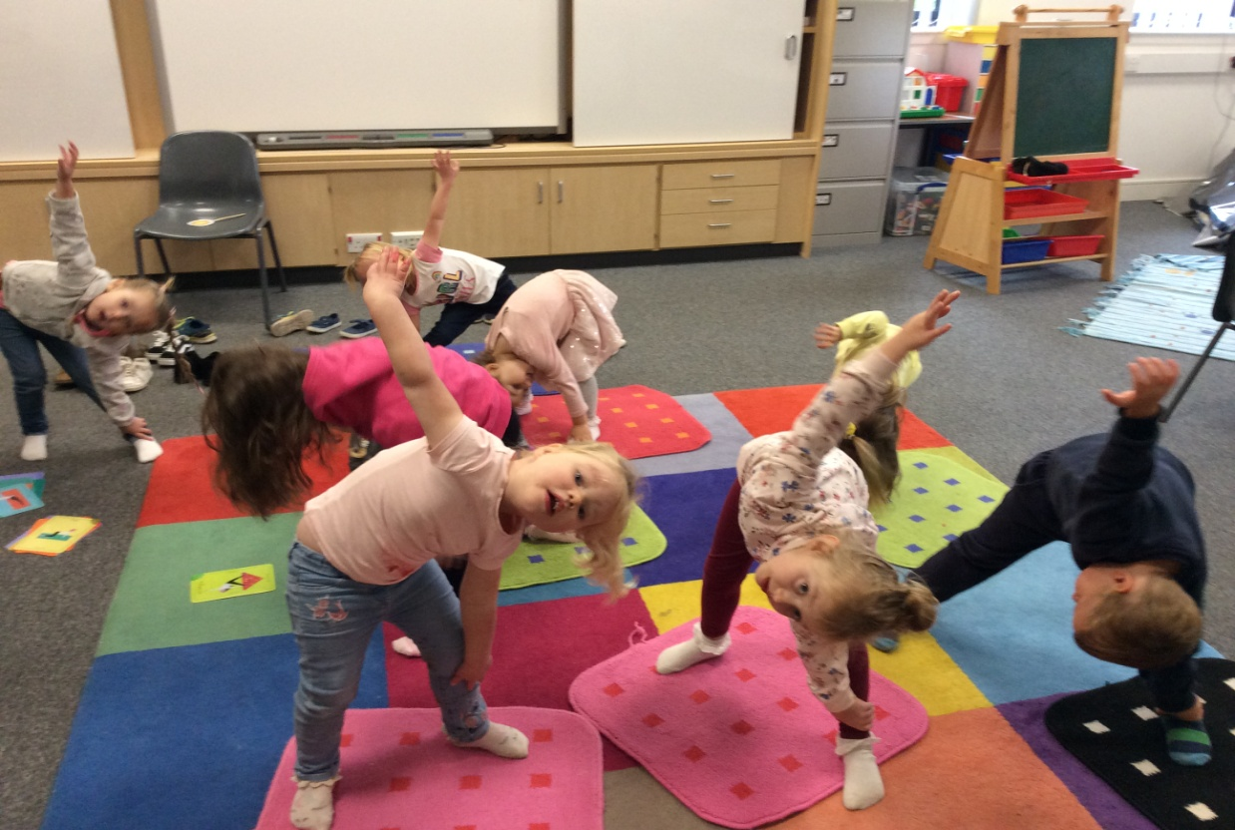
MEDICATION
If your child is in need of medication during his/her time at nursery, you should discuss his/her requirements with the nursery teacher. Prescribed drugs will be given at the discretion of the Head Teacher and you will be required to fill in a form, which authorises nursery staff to administer the medication to your child. These forms are available from the school office.
If your child suffers from asthma or other allergies, you must tell the nursery staff if there are any activities or specific circumstances, which are likely to bring on an attack.
If your child suffers from epileptic seizures, diabetes etc., you must tell the staff what emergency procedures are to be followed.
IF YOUR CHILD BECOMES UNWELL
The staff would welcome a telephone call within the first half hour of the nursery session if your child is not able to attend nursery on a particular day.
If your child becomes ill when at nursery, contact will be made with you or your emergency contact. It is imperative that emergency contact details are kept up-to-date.
We will obtain medical attention as appropriate e.g. call an ambulance if necessary.
It is useful to notify the nursery of infectious illnesses such as chicken pox so that we pass this information to other parents.

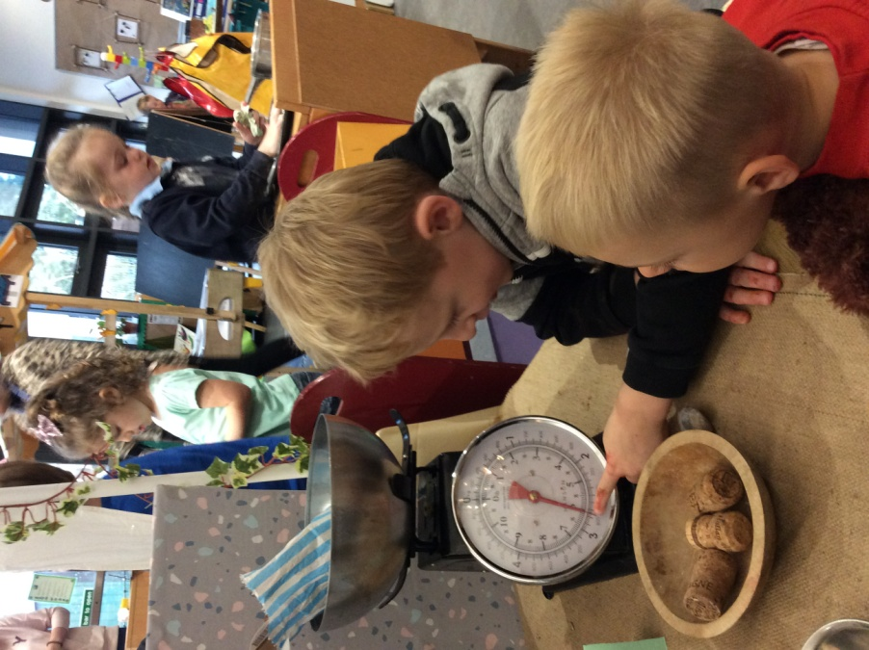
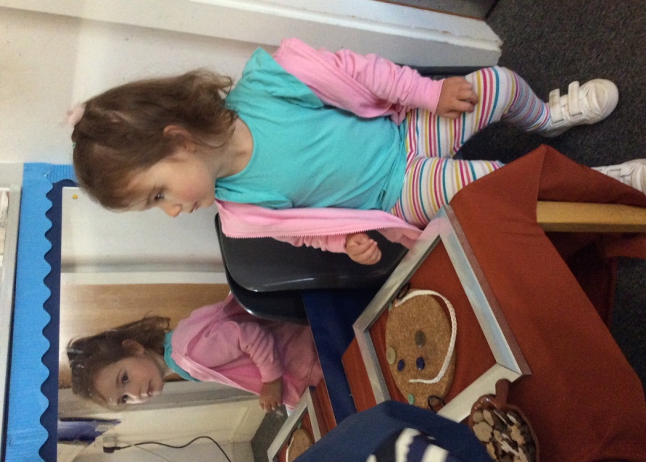

In the case of sickness and diarrhoea, your child must be 48 hours clear of symptoms before returning to nursery.

MINOR ACCIDENTS AND UPSETS
Although we hope that these will be few and far between, realistically there will be occasions when they do occur.
Our nursery staff are highly trained and extremely sympathetic. They will comfort your child and deal with each incident at they see fit.
You will be informed of the occurrence of ay minor accident. There are trained first aiders on the premises.
If your child receives a minor bump on the head, we will alert you to this when they are collected.
You will be asked to sign our incident book when you collect your child.
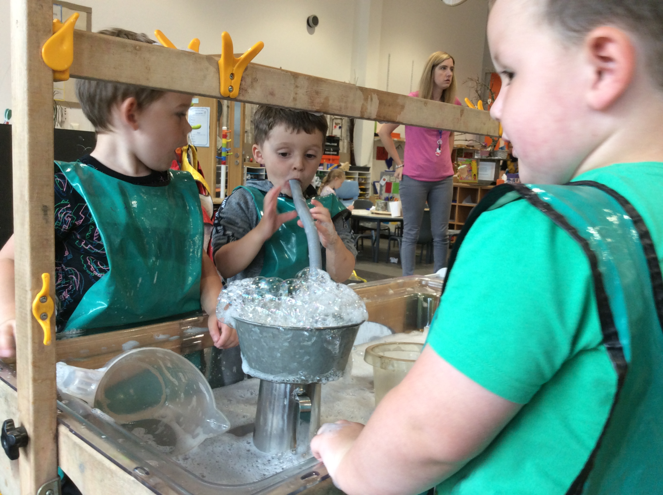
CHILD PROTECTION
Midlothian Council has Child Protection Guidance in place, which all staff must follow to promote the welfare of children and to protect them from harm.
All adults must share the responsibility for promoting children’s health and safety and ensuring, as far as possible, that all children are protected from abuse, neglect and exploitation. Children cannot be expected to take full responsibility for keeping themselves safe. Professional staff must work together in co-operation with families and carers to enable children to grow up in a warm, stimulating and safe environment.
Education staff are required to assist in the protection of children by:
- Creating and maintaining a positive and caring ethos
- Developing health and personal safety programmes
- Being observant of children’s needs, views and concerns
- Reporting and recording concerns about the welfare or safety of children
- Monitoring and supporting children in co-operation with relevant professionals, parents and carers.
Education staff cannot keep secret any allegations or concerns about child abuse, even if a child or adult request this. Information or concerns that a child may be at risk or harm must be passed on in order to protect the child. Staff will treat the matter sensitively and information will only be passed to those who need to know in order to protect and support the child.
If parents or others have concerns for any child, they can speak to the Head Teacher about this. They can also contact social work services and/or the police.
When a member of staff, a child or another individual provides information and the Head Teacher considers that there is a possibility that a child has been harmed or is at risk of harm, the Head Teacher is required to immediately contact social work services to discuss the circumstances and agree the immediate action to be taken. School staff are then required to co-operate with any subsequent enquiries or support plans.
Every education establishment or service has copies of the Midlothian Council Child Protection Procedures and Guidance. These are available for reference from the Head Teacher.
Child Protection Co-ordinator – Claire Bond (Head Teacher)
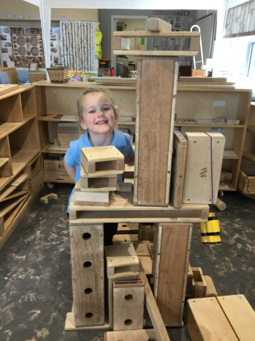
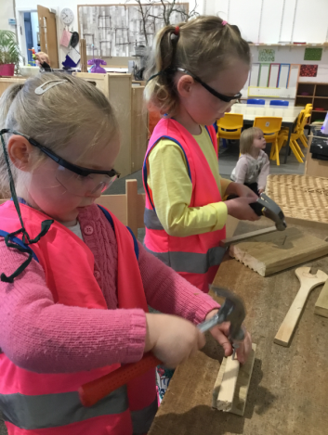

THE NURSERY CURRICULUM
The Learning Environment

The eight curricular areas of A Curriculum for Excellence are:
- Health and Wellbeing
- Literacy and English
- Numeracy and Mathematics
- Expressive Arts
- Science
- Social Studies
- Technologies
- Religious and Moral Education

The whole child is important. We consider the physical, intellectual, linguistic, emotional and social aspects of a child’s development to be so closely related as to warrant equal consideration.

Each child is recognised as an individual who builds his or her own knowledge through activities shared with supportive adults. One of the chief concerns of the nursery curriculum is that the staff accepts the child as he or she is - linguistically, culturally and developmentally. Children are active participants in building their own curriculum.

This results almost invariably in a positive and supportive relationship between staff and children, which is important for social and emotional growth. Children are encouraged to have control over what happens to them and to be in charge of their own activities. With the appropriate kind of adult support a child’s sense of self-worth and independence are strengthened.

We try to provide a wide range of learning activities that we hope the children will find challenging, interesting and fulfilling. Ample opportunity is given to explore and experiment at their own level.

The Importance of Play

The staff team is fully aware of the importance of play as a powerful contribution to children’s learning and is committed to providing a ‘play-based curriculum’. It is through play that young children learn and make sense of their world. In different play contexts children will gain experience of communicating, practicing, exploring, discovering, investigating, experimenting and problem solving. By observing children in play situations we can identify strategies to help us in our planning to support and extend learning.

Curriculum for Excellence aims to achieve transformation in education in Scotland by providing a coherent, more flexible and enriched curriculum from 3-18. It is about bringing life to learning and learning to life. It focuses on the importance of knowledge and skills. It offers a broad and deep general education to S3 with options in the senior phase. It promotes the ability to learn skills for life that will help young people go on to further study, to secure work and to navigate through life. It brings real life into the classroom and takes lessons beyond the classroom.
Curriculum for Excellence promises to support children in every way possible so that they can fulfil their potential and make the most of their opportunities. All those working with children and young people will be responsible for delivering skills in literacy and numeracy, skills that unlock other subjects and are vital in everyday life. All staff will be responsible for young people’s health and wellbeing and for identifying the personal support a child needs on a day to day basis. Parents can ask for help too.
Staff will work together to plan a child’s ‘learning journey’ from 3 to 18. They will ensure young people can learn in a way that works for them; at a pace, they can cope with and with enough challenge to stretch them. Staff will support them as they move up from nursery to primary, on to secondary and beyond.
Professionals can teach subjects more creatively, work together and with others, and share best practice, ideas and innovation. Ultimately, the aim is to improve our children’s achievements and life changes, to nurture successful learners, confident individuals, effective contributors, and responsible citizens.

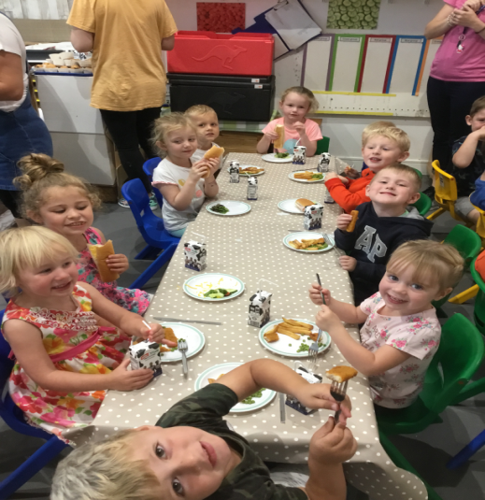
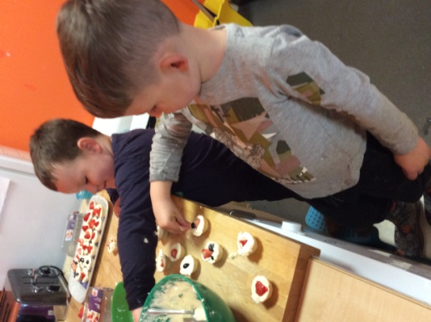
Successful Learners  With  - Enthusiasm and motivation for learning  - Determination to reach high standards of achievement  - Openness to new, thinking and ideas  And able to  - Use literacy, communication and numeracy skills  - Use technology for learning  - Thing creatively and independently  - Learn independently and as part of a group  - Make reasoned evaluations  - Link and apply different kinds of learning in new situations |  | Confident Individuals  With  - Self-respect  - A sense of physical, mental and emotional wellbeing  - Secure values and beliefs  - ambition  And able to  - Relate to others and manage themselves  - Pursue a healthy and active lifestyle  - Be self-aware  - Develop and communicate their own beliefs and view of the world  - Live as independently as they can  - Assess risk and take informed decisions  - Achieve success in different areas of activity
TO ENABLE ALL YOUNG PEOPLE TO BECOME
Responsible Citizens  With  - Respect for others  - Commitment to participate responsibly in political, social and cultural life  And able to  - Develop knowledge and understanding of the world and Scotland’s place in it  - Understand different beliefs and cultures  - Make informed choices and decisions  - Evaluate environmental, scientific and technological issues  - Develop informed, ethical views of complex issues |  | Effective Contributors  With  - With enterprising attitude  - Resilience  - Self-reliance  And able to  - Communicate in different ways and in different settings  - Work in partnership and in teams  - Take the initiative and lead  - Apply critical thinking in new contexts  - Create and develop  - Solve problems

CARE STANDARDS
At Cuiken Primary Nursery Class, we refer to the national are standards to ensure that we are supplying a good quality service for both you and your child. These standards provide the framework for assessing the service as a whole. In our nursery, we audit the curriculum, children’s progress, assessment, support for learning and quality assurance.
The Care Inspectorate inspect the service on a two yearly basis to ensure that we are meeting the regulations and in doing so are taking account of the national care standards.
If you would like more information about the Care Inspectorate, please look at the website (http://www.scswis.com)
We have a copy of the National Care Standards on the notice board in the nursery. Parents are always welcome to have a look.

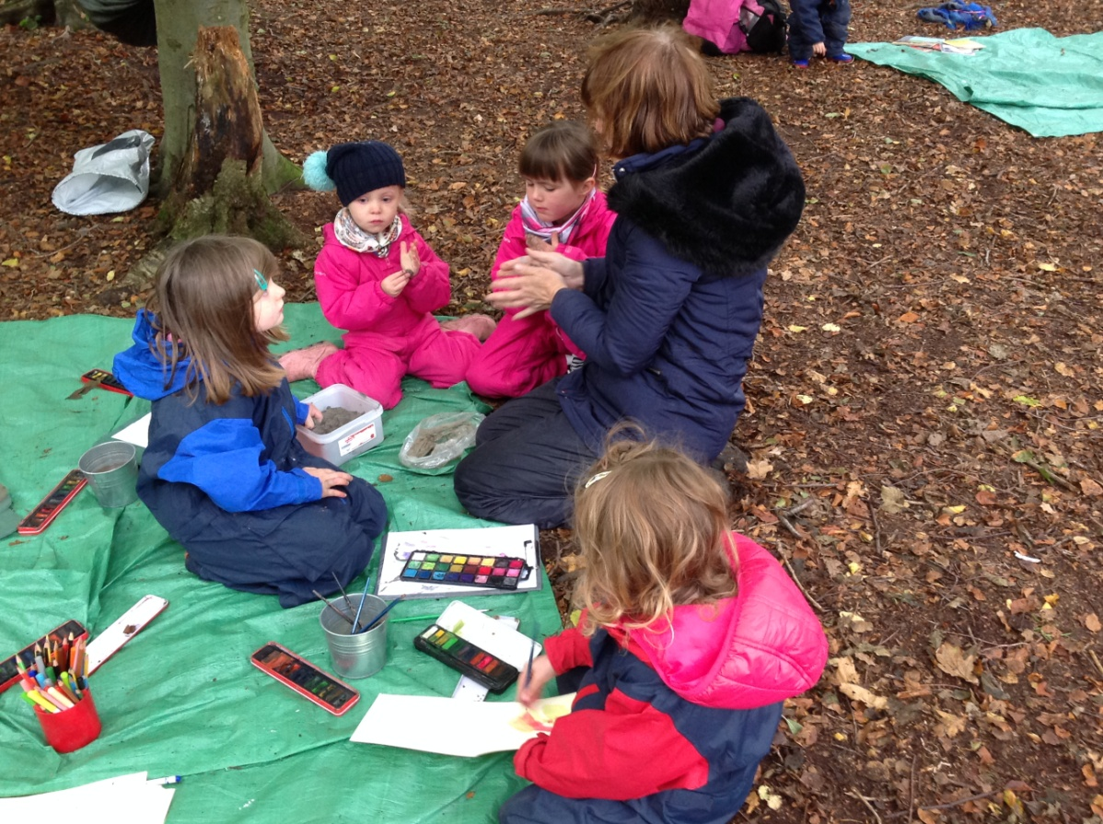
HOW WE PROMOTE LEARNING
We promote learning in our nursery class by:
- Planning clear goals for children’s learning.
These are designed to match the needs and achievements of all children.
- Through observation of children at play.
By using this procedure our staff become aware of how and what your chid is learning.
- Keeping records of observations and assessments.
This enables us to plan learning experiences, which take account of the children’s needs and developments.
- Using reporting as a means of promoting partnership with parents.
You may discuss your child’s progress formally or informally with any member of staff. We encourage you to ask questions relating to your child’s progress and to share any information, which you feel is relevant with us.
- Assessing children’s development and progress.
In doing this we aim to take account of all your child’s needs i.e. physical, social, emotional, aesthetic and educational development. Our assessment is a continuous process, which is carried out by observing, listening and talking to your child in the course of everyday activities. You will be invited to take part in the assessment of your child by means of informal chats and if necessary in more formal circumstances. We wish to emphasise that your child’s own progress is the basis of our assessment, rather than his/her progress in relation to other children.
- Responsive Planning
Children learn best when planned learning and teaching experiences meets their needs and interests. Children’s interests are developed and progressed in small groups. Floorbooks and learning walls are used to record and track learning and are available for parents to view.

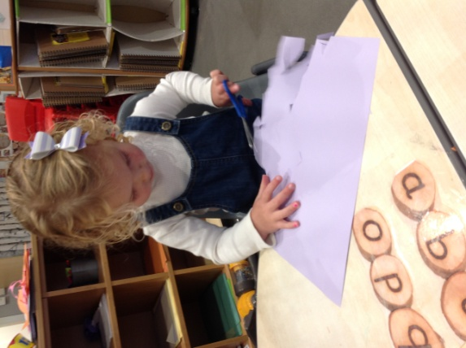
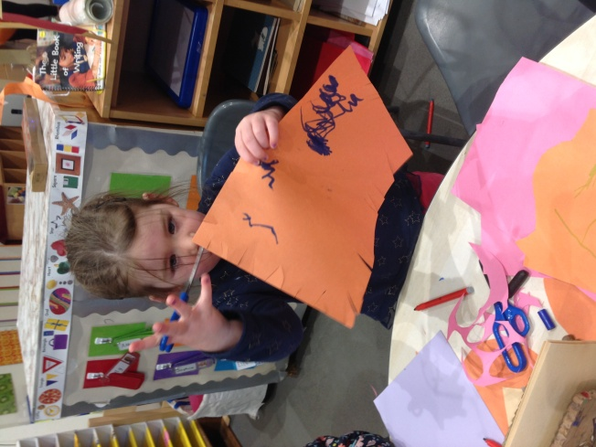

SUPPORTING CHILDREN

All children have different needs and at some point during their school life, we may need to offer extra support. Often this support is temporary and can be removed as the child develops. This is the case in pre-five education as it is in primary and secondary education.

Additional support can be related to specific aspects of learning, for example speech and language development. In some circumstances and in consultation with parents, we can seek advice and support from external agencies such as speech and language therapists and psychological services.

If your child requires additional support, the nursery staff will monitor his/her progress carefully and ensure that an individual educational programme is in place if necessary. You will be consulted about this and asked to work in partnership with us.

Regular reviews of your child’s progress will take place and all interested parties will participate in the discussion about the progress being made, the targets to be set and the next steps in your child’s learning.

A small proportion of children require long-term support and regular reviews with parents, nursery staff and other professionals are held in order to monitor progress.

It is important that parents, nursery staff and other professional bodies work together to support children’s learning. By doing this we are ensuring that each child has the opportunity to achieve his/her potential.
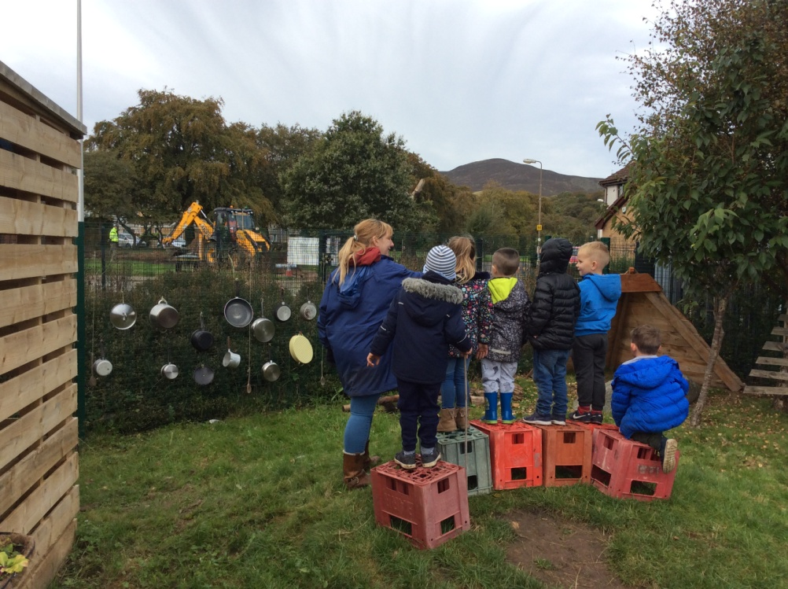

PARTNERSHIP WITH PARENTS/CARERS
In Cuiken Nursery Class we aim to:
- Involve parents/carers in decisions that are taken about their children’s education.
- Establish and maintain a two-way channel of communication with parents/carers.
- Share experiences and keep parents/carers informed of developments within the nursery.
Our staff will always be happy to discuss your child’s progress with you and you are welcome to visit the nursery at any time. We value your role in your child’s learning. As parents/carers, you are the prime educator in your child’s early years and we hope that you will continue to play a major role in your child’s learning when he/she comes to our nursery.
We welcome any contributions you may wish to make and look forward to establishing a positive relationship with you.
CHANGE IN CIRCUMSTANCES
It is helpful to keep the nursery staff informed of anything happening at home that might affect your child e.g. birth of a baby, death of a relative etc. It will help us understand what is going on and enable us to give suitable support. Anything you tell us will, of course, be treated with complete confidentiality.

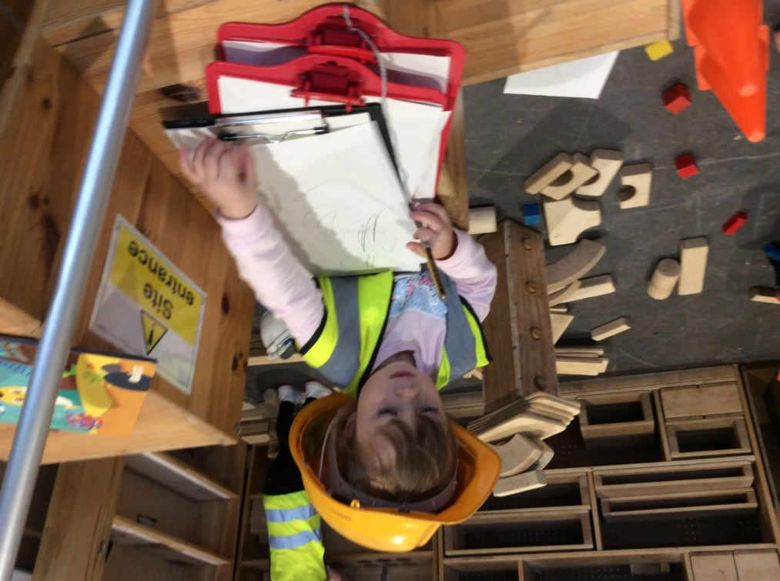

WORKING TOGETHER TO PROMOTE POSITIVE BEHAVIOUR

It is our policy at Cuiken Primary to promote positive behaviour. This is achieved by:
- Use of praise and positive reinforcement
- Encouraging our children to respect other children and adults
- Encouraging our children to respect the property of others
- Establish routines and practices as part of the nursery programme.
Very occasionally a child has difficulty settling into the nursery routine and this can manifest in inappropriate behaviour.
If this occurs, a member of staff will chat with parents/carers and look for a way forward. If difficulties persist this will be seen as a need for additional support and steps will be taken, similar to those outlined in the chapter ‘Supporting Children’.
All of this will involve joint decision making with parents/carers involved at every stage.

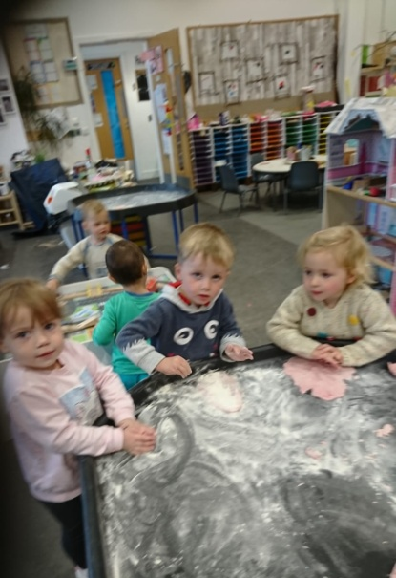
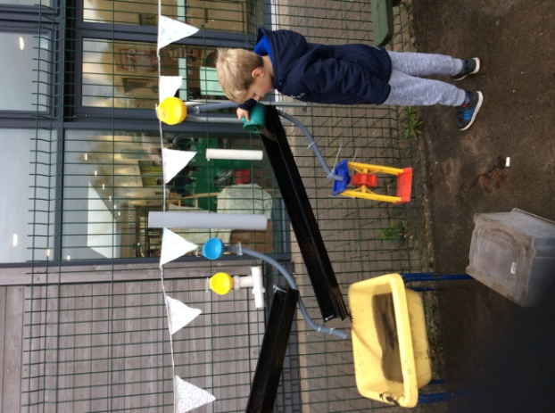

SCHOOL AND COMMUNITY INFORMATION

COMMUNICATION

The primary school and nursery issue regular newsletters that contain current information and a calendar of events. The weekly plan and other important items are posted on the nursery notice board and on the school website.

Good communication between staff and parents/carers is important. The closer we work together the more we can benefit your child. Help us to help your child by telling us about anything at all which may be worrying either of you.

We welcome constructive criticism and are always willing to discuss any problems that may arise. Please feel free to put comments in our suggestion box which is located in the entrance foyer.

Information will be posted on our outside noticeboard and within the cloakroom area. Regular information is issued to parents/carers through letters and a nursery newsletter. If you require additional information on any subject, please do not hesitate to contact a member of the nursery staff. Cuiken Primary School Parent Council will welcome the involvement of any of our nursery parents.
THE LOCAL COMMUNITY
In Cuiken Primary, we place a great deal of importance in our children having access to the local community. Visits to locations within the local area will be organised and members of the community may be invited to the nursery to meet the children.
LINKS WITH CUIKEN PRIMARY SCHOOL
The nursery class is part of Cuiken Primary School and children will have access to many of the resources within the school.
The school gym hall is timetabled to allow the nursery children to use it for physical activities. Children are invited to take in the assembly. The children are also given the opportunity to take part in nature play.
All nursery children are fully involved in the whole school events e.g. Assemblies, Scottish Week, Health Week, and the ECO Committee. We aim to encourage the nursery children to feel at ease within the primary school.

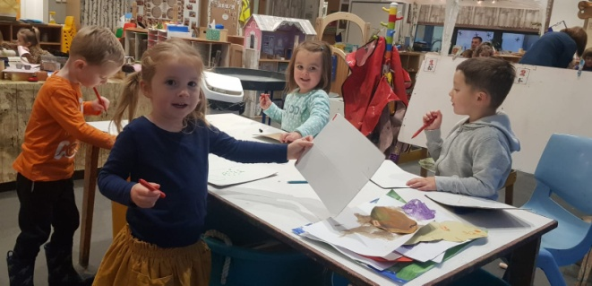

School App
We will be using our school app going forward for all communication. On the App you can find diary dates, news, information, letters and links to our Twitter and website.

How to download our school app…

Step 1- Download the app from the app store on your phone.

Step 2- Choose ‘Cuiken Primary school’ from the drop down menu.
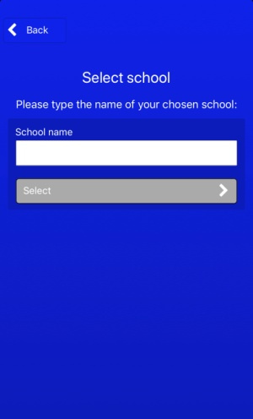

Step 3 – Log in with User name – Cuiken

Password - 4580

TRANSITION FROM NURSERY TO PRIMARY
There are many transition arrangements in place to support a smooth journey for your child as they move to Primary 1 whether at Cuiken Primary School or another school. Before leaving nursery, a transfer of information record for each child will be prepared by the nursery staff to ensure a smooth transition and continuity of education for the child transferring to primary.
Primary School Admissions
When commencing Primary 1 education, your child will normally attend the local denominational or non-denominational Primary school regardless of religion and transfer from it, after Primary 7, to its associated Secondary School. Details of the catchment areas and boundaries can be obtained from the school office.
Enrolment dates will be set by each school and the enrolment should be completed in November prior to the start of term in August. The authority will place adverts in the local press and nurseries advertising the date(s) for enrolment. Enrolment forms should be completed on enrolment day at your catchment school. Parents are asked to bring the relevant birth certificate(s) and proof of residency when enrolling their child (ren).
You are still required to enrol your child (ren) at your catchment school even if you do not wish him/her to attend that school.
Enrolment timetables will also be available through Midlothian Council Website.
Children eligible for enrolment are those whose 5th birthday falls between 1st March and the end of February the following year.

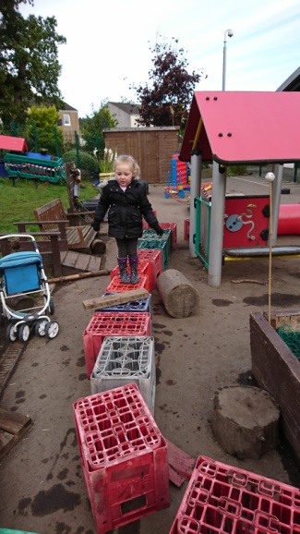
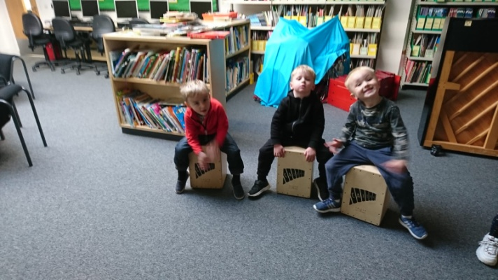

SUGGESTIONS AND CONCERNS
We are always anxious to maintain and improve our service. If you have any suggestions to make about the service, please contact the Head Teacher in the first instance. If you feel your concern has not been satisfactorily resolved with the Head Teacher, please contact the head of service with responsibility for pre-five education who can be contact at the following address:

Julie Fox
8 Lothian Road
Dalkeith
EH22 3ZG
As a Registered Care Service you are also entitled to contact the Care Inspectorate directly regarding any complaints by:
- filling in their complaints form online
- contacting by phone on 0345 600 9527
- write to any of the Care Inspectorate Offices
Whichever method you use to, they will deal with your complaint following their Complaints Procedure.
In summary, this means they will:
- acknowledge that they have received your complaint within three working days
- aim to complete the investigation within 40 working days.
- let you know if they think there will be a delay, and give you the reasons for any delay
- let you know their findings and the outcome of the complaint.
See more at:
http://www.scswis.com

USEFUL ADDRESSES

Based at Fairfield House, 8 Lothian Road, Dalkeith EH22 3ZG
Chief Executive | Grace Vickers | 0131 271 3002
Director, Education, Communities and Economy | Mary Smith | 0131 271 3718
Head of Education | Maria Lloyd | 0131 271 3719

Please Note:
Although the information is correct at the time of printing there could be changes, affecting any of the matters dealt with in it, either before your child’s placement or during the course of their placement. The Head Teacher will tell you of any important changes to the information.

