Social Studies- Birds  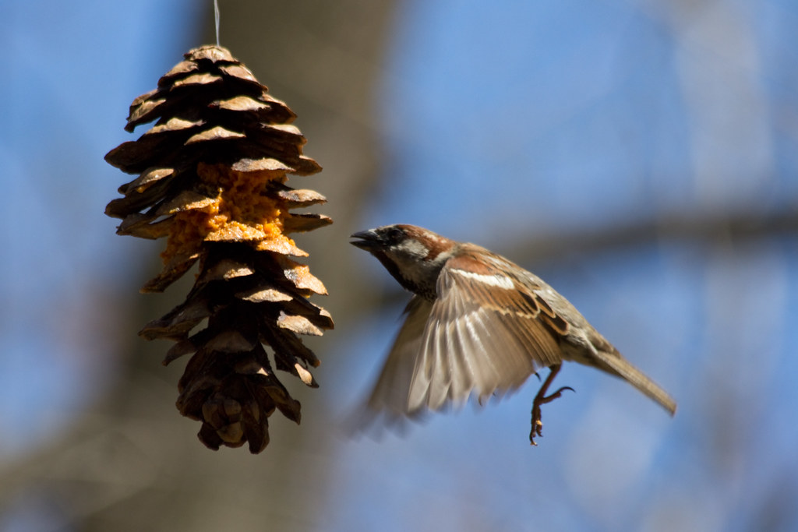  Click on the link below to take you to a video on how to make your own bird feeder.  https://youtu.be/P9BFnTQR-L8 | Health and Well-Being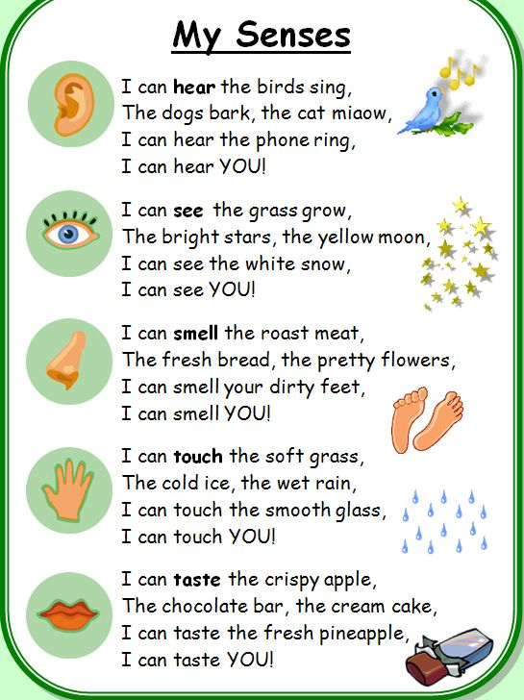 | Social Studies  ttps://www.rspb.org.uk/globalassets/downloads/kids--schools/teaching-resources/make-a-rock-pile.pdf  Can you help nature and build a rock pile for insects?  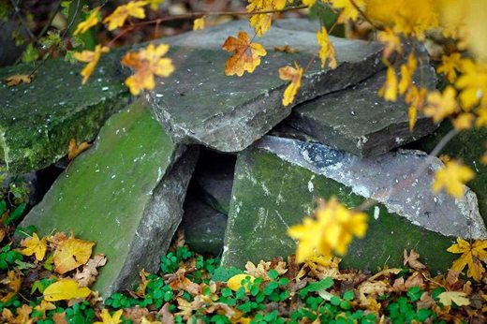
Numeracy  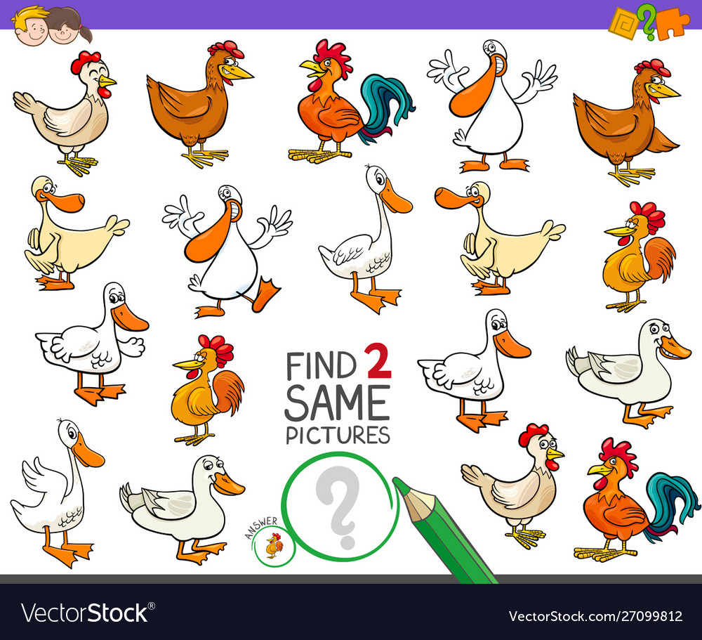  Can you find 2 birds the same? | Counting  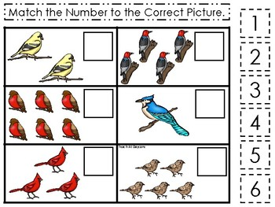  Can you count how many birds there are?  Do you know the names of any of the birds? | Music/Song  Click on the link below to take you to a sing- along- song.  https://youtu.be/lryk31wxqlQ

