0

**Health and Wellbeing**

Our PE days are Wednesday (P4a), and Thursday (P4b). PE will take place outside in line with current guidelines at the moment. Your child should come to school in sportswear on these days. We will be accessing our outdoor spaces much more so please ensure your child has a waterproof jacket, layers and appropriate footwear.

A huge amount of the work we are doing this term is focused on the health and wellbeing of our children in light of Covid-19. We are using many picture books and stories as a way of engaging the children in reflection and discussion of their feelings and emotions.

**Ideas for Learning at Home**

Digital technology will definitely play a part in home learning this year!

Home reading will be slightly different this term as no books can come home YET! The Oxford Owl e-library is an excellent resource to help engage with similar texts at home. This is free to access and we encourage you to register and log-in. <https://home.oxfordowl.co.uk/>

Spelling: each week your child’s spelling list is added to Spelling City. There are lots of fun activities to help your child learn and embed the spelling patterns and tricky words.

We will be in touch to make sure everyone has a note of their username and passwords for Spelling City, Education City and Sumdog.

**Names on clothes**

Please ensure that children have their names clearly labelled. This includes school sweatshirts, jumpers, cardigans, footwear and gym shoes as well as all gym kit. Already there are a large number of items in lost property.

‘Meet the Teacher’/Parent’s Evening will be slightly different. Our Curriculum Booklet for P4 will follow soon. Hopefully, this will give you more information. Please do not hesitate to get in touch if you have any questions by emailing the school office.

Miss Gunn and Mr Garwood

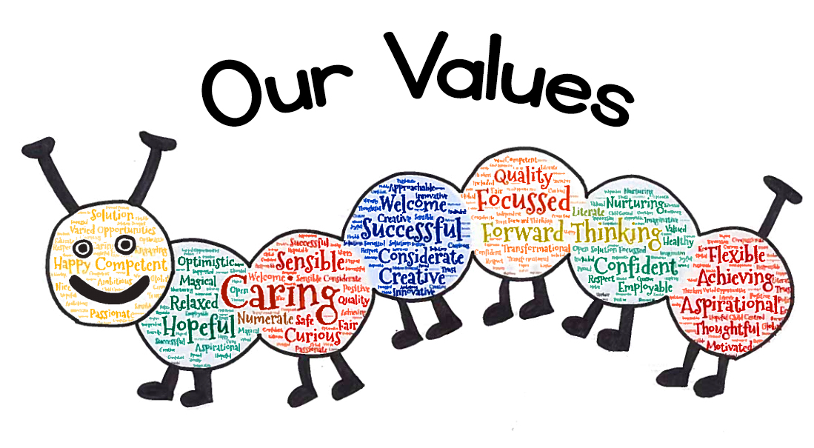

**Primary 4 Newsletter – Term 1**

Welcome to the Primary 4 newsletter! Here you will find information about what is going on in Primary 4 this term.

Many things will be a bit different from what has happened before. We shall all be learning together and make changes as we need to as we go along!

**Literacy**

Children will work on spelling patterns and common words. You can support these at home using Spelling City. In class we shall be reading a novel together, and reading groups will be taking place. Our focus for writing will be Imaginative, concentrating on character and setting. We will work on listening skills, in particular listening to and following instructions.

**Numeracy and Maths**

This term, there will be a focus on addition and subtraction, multiplication, division, time and place value. Practising tables knowledge at any opportunity will always be helpful. The way that we teach Numeracy and Maths provide several strategies across different concepts to ensure Personalisation and Choice.

**Learning Across the Curriculum**

This term there will be a focus on Harvest and food chains. We will look at how far our food travels, before we get to eat it, and where our food comes from.

**Wider Achievements**

If your child has accomplished any new achievements outside school please encourage them to let us know!