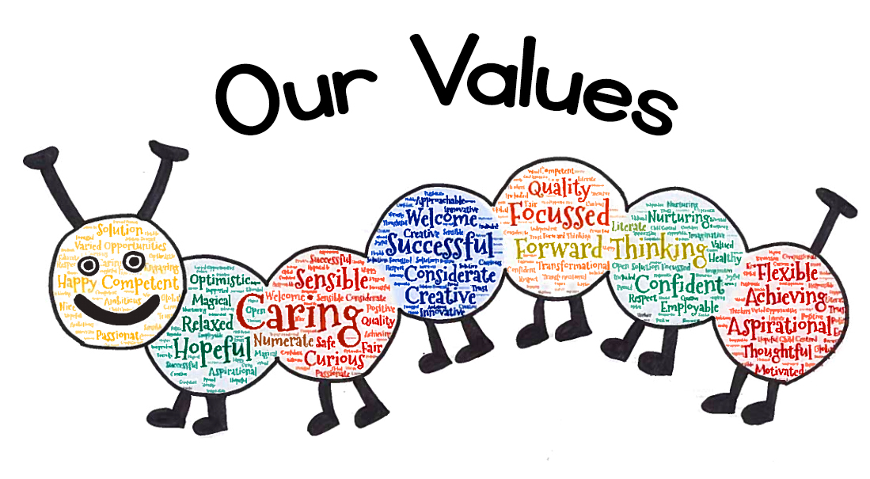

**Primary 3 Newsletter – Term 1**

Welcome to the Primary 3 newsletter! Here you will find information about what is going on in Primary 3 this term. We are delighted to be reunited with our pupils and are enjoying getting to know one another this term. P3 might look a little different this year but we are sure a positive, productive and safe time can be had by all! We hope you are enjoying our soft start and end to the day.

**Literacy** –

We have been making sure that the children have a fundamental and secure knowledge of phonics, reading and writing as part of our recovery from lockdown. We are focusing on sentence structure, including correct punctuation; capital letters, finger spaces and full stops. We are revising our knowledge and use of grammar; including nouns, adjectives and verbs, and have been working hard to recall phonics, tricky words and spelling patterns taught last year. Everyone has been issued with a reading book (this must stay in school at the moment) and regular reading sessions are taking place, in groups, across the week. We are revisiting storytelling and story writing this term, focusing on planning using story mountains and story maps, building character description and describing settings.

**Numeracy and Maths** –

Again, much of our Numeracy and Maths will be revision and assessment of where the children are at. We have been working on basic maths facts; place value and revisiting the **4 operations; addition, subtraction, multiplication and division.**

In Maths, we have been working on area, time, shape, pattern and capacity.

**Learning Across the Curriculum** –

We will be reintroducing French, RME, Science and Social Studies. Our Science topic this term is Water. We will be learning about the processes of planet earth and how water can change from one form to another. Our Social Studies topic is Weather. We plan to create a range of instruments to measure and record the weather and discuss how weather affects our lives.

**Wider Achievements** -

If your child has accomplished any new achievements outside school please encourage them to let us know! We use informal ‘show and tell’ at points during the week where children can share their achievements or other items with the class. Unfortunately, children cannot bring items to show at the present time.

**Health and Wellbeing** -

Primary 3A have PE on Tuesday and Thursday. Primary 3B have PE on a Tuesday and Wednesday. PE will take place outside in line with current guidelines. Your child should come to school in sportswear on these days. We will be accessing our outdoor spaces much more so please ensure your child has a waterproof jacket, layers and appropriate footwear.

A huge amount of the work we are doing this term is focused on the health and wellbeing of our children in light of Covid-19. We are are using many picture books and stories as a way of engaging the children in reflection and discussion of their feelings and emotions. Our favourites being; The Colour Monster by Anna Llenas, The Worrysaurus by Rachel Bright and Ruby’s Worry by Tom Percival. We have also used art therapy in class to help the children express their emotions. The children have created self-portraits and worry dolls.

**Ideas for Learning at Home**-

Digital technology will definitely play a part in home learning this year!

Home reading will be slightly different this term, as no books can come home YET! The Oxford Owl e-library is an excellent resource to help engage with similar texts at home. This is free to access and we encourage you to register and log-in. <https://home.oxfordowl.co.uk/>

Spelling: Each week your child’s spelling list will be added to Spelling City. There are lots of fun activities to help your child learn and embed the spelling patterns and tricky words.

We are working on generating passwords and logins and will be in touch soon to make sure everyone has a note of their username and passwords for Spelling City, Education City and Sumdog.

**Names on clothes** –

Please ensure that children have their clothes clearly labelled. This includes school sweatshirts, jumpers, cardigans, footwear and gym shoes as well as all gym kit.

Our Curriculum Booklet for P3 will follow soon and keep an eye on the school app for details of parents’ consultations. Please do not hesitate to get in touch if you have any questions by emailing the school office.

Mrs Bowman, Mrs Sneddon and Miss Edmond