Weekly Task – Green Dinosaurs and Blue Dolphins (01:02:2021)
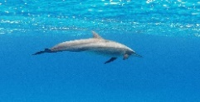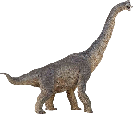
Hello again! We hope you are well. Thank you to everyone who managed to send us some photos of las week’s tasks, we really enjoyed looking at them and we have added them to your learning profiles. This week’s task is to make sock puppets (or any type of puppet). You can use any resources you have in your home or garden, but here are some ideas of what you might need;
Old odd socks
Googlie eyes
Pens – to draw a mouth/face Wool
Pipe cleaners
Buttons
Glue or needle and thread
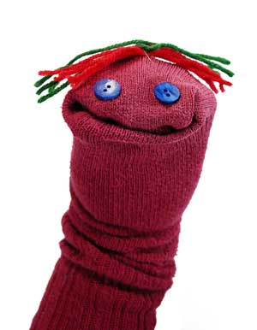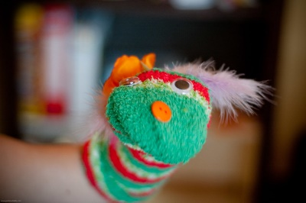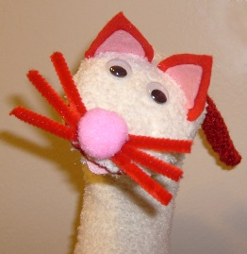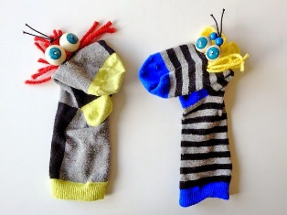
Once you have made your puppet/puppets why not act out one of your favourite stories, or you could even make up your own story! Maybe you could construct a puppet show stage using a big box, or create some scenery. Why not perform your story (or puppet show) for your family. Perhaps your grown up could video your performances and share it with you?
Remember to take photos and let us know how you got on. What did you enjoy most about this task? Did you find any bits tricky? How did you feel when you were performing? If you do this again, what could you do differently?
To help you and your grown-ups relax, why not try some YOGA. If you search for Cosmic Kids yoga, you will find many wonderful stories to stretch and balance your way through.
As always, we look forward to seeing all your photos and hearing all about your learning, so don’t forget to contact us on bilston.ps@midlothian.gov.uk
Happy learning!
From
Mrs Marwick and Miss O’Hara

